NYSFAAA Region 1 Meeting 2/11/21 Virtual
Attendees

Laura Worley- Credit Union Student Choice
Marianne Loper - Houghton
Tom Dalton - EdAmerica
Pam Beehler – Niagara U
Kathy Michalski - NCCC
Jennifer Garey – Niagara U
Katie Rusek - D’Youville
Jim Trimboli - NCCC
Katie Kocsis – Niagara U
Julie Almendinger – Canisius College
Nicole Griffo - Hilbert
Gene Pohancek _D’Youville
Terry Adamczyk – Trocaire
Brian Murphy - DOE
Sue Barber – Niagara U
Stephanie Schroeder – D’Youville
Christine LaPresta – Niagara U
Howard Nance - DOE
Sarah Cybart - Fredonia
Dan Hunter - Emeritus
Elaine Szczepanski - Hilbert
Colleen Long – Buffalo State
Sandy Looker – Daemen College
Tracy McVeigh – Buffalo State

Barb Suraini – D’Youville

Treasurer’s Report – Kathy Michalski
NYSFAAA Treasury (from Lea Nuwer)
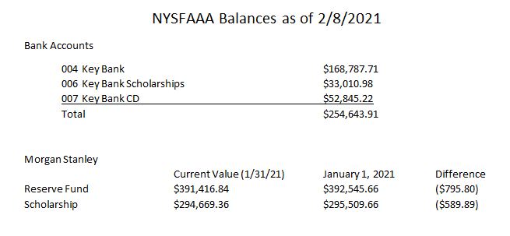
Region 1 Treasury
$3657.09 Previous Balance
-20.00 Tim Hortons gift cards for holiday game winners

$3637.09 Current Balance

Membership Report – Marianne Loper
Membership is down. The Membership committee is meeting soon. Send any ideas for increasing membership to Marianne.
Laura received a list of members who did not renew. Some are not in the area anymore, or not in Financial Aid. Maybe we should reach out to Directors to encourage staff to join. Maybe lower cost? An institutional membership fee has already been denied.
The NYSFAAA training on 2/10 was a good example of why there needs to be increased or expanded membership. There are people in the business office that need to be privy to this kind of training or information. Federal and State initiatives involve more than just the Financial Aid office.
SUNY budgets have been greatly reduced so many schools no longer pay for membership dues for individuals. Schools need to justify why membership needs to be supported and included in budgets.
Please email any ideas on how to increase membership to Marianne.Loper@Houghton.edu
New Business / Discussions
We’ll have a March meeting on March 18 with a presentation from Tom Dalton and a HEERF discussion, plus a HESC update.
Jim Trimboli requested examples of other schools’ (private schools) CARES applications for students. jtrimboli@niagaracc.suny.edu
Please send any comments or suggestions regarding technology, social media, or the NYSFAAA website to Sandy Looker. Slooker@daemen.edu
Training
Brian Murphy, Special Agent and Howard Nance, Special Agent
US DOE Office of Inspector General, Investigation Services
1-800-MIS-USED
The presentation will be made available by Laura.
Exec Council Report – Lea Nuwer
Adrienne King went to the January TAP Work Group meeting. They discussed holding students harmless throughout the emergency, COVID's effects on Excelsior and other aid programs, and the 20% pay withholding.
Adrienne signed contracts for Zoom and Whova to improve our virtual Novice and Conference experiences.
Novice will be half days from June 7 -11.
Regions and committees should use the calendar function of the website.
Howard Leslie has finalized the roster of members of the Government and Ethics committee.
Start preparing for election nominations. Ballot should be ready by May 2nd.
The Membership committee is working on lapsed memberships, and checking the Affiliates to make sure they are in the proper grouping.
Zoom is up and working. Statewide Training has put events on the website calendar.
TICC is working on a scheduled social media plan, and possibly a Facebook page for members.
The website homepage and member landing page both have links to Student Advocacy 2021. You can get involved with Government Relations committee, see our Talking Points, and get the contact info for NYS Senators and Assemblypersons.
The NASFAA trainings are successful so far.
There is a survey out this week regarding 2021 conference preferences. Please take a moment to complete it.
The 2022 conference committee is clarifying contractual obligations with the venue in the event we are virtual for that conference as well.
HESC is sending out a Bulletin. Send in the Participation Agreement by March 3rd. They have removed the 45 day deadline for APTS recipient list. Complete the College Data Survey even if you do not know the tuition rate yet. They need the contact info. HESC is starting to process 21-22 Student Status Listing. They need ID's. They have been running IVP, requesting info and citizenship documentation. The 20-21 certification process starting paying January at 100% of value.
Government Relations is speaking directly to members of NYS Senate and Assembly during these advocate days. They are also meeting with Elsa McGee from HESC. They are using our talking points. They will reach out to region Chairs to identify a person with whom they can assist with scheduling advocacy appointments. Government Relations will try to attend meetings with members. Adrienne and Chris Barto will send a link to the talking points to the Assembly and Senate members.

All Exec Counsel meetings this spring are virtual. Next meeting is April 28th from 1 - 4. The budget meeting will by June 14th from 9-5 and June 15th from 9 - 12.

Minutes submitted by Sandy Looker, Daemen College, Region 1 Secretary slooker@daemen.edu

