Howard Leslie’s Response to Unanswered Questions as Well as Questions Received Since

Please note that all my responses are based on my current knowledge and through research. With final interim regulations due in the Spring 2026 and much more department guidance to follow, anything can change.

Question 1
Does the limit have to be per program or could you limit say the parent plus loans to, $16,250/year so they are not out of eligibility in the last year
Answer:
A school may choose to impose limits on student (Direct Subsidized/Unsubsidized) loans while NOT placing limits on Parent PLUS loans, as long as the school follows basic Title IV rules about consistency, nondiscrimination, and transparency.
Likewise, a school may choose to impose limits on just Parent PLUS loans.
To be clear, the limitation law speaks mostly to programs of study, not loan programs. This is to ensure that there is not a case-by-case determination to limit any loans.

Question 2
If we have a list of students to call COD to grandfather, will they let us go through our list on the phone? Or will we need to call for each and every one?
Answer:
Your guess is as good as mine. My hope is that they eliminate the phone call process by:
- Flagging the student through their systems or better
- Enable their systems to see prior-year loans

Question 3
it seems the word "drop" and "withdraw" are being used interchangeably. Tamy Abernathy made the distinction at the FSA conference that if a student withdraws and is still considered full time based on policy. We would not reduce the loan.
Answer:
My understanding is that if a student remains enrolled past the add/drop period and has begun attending the course they later withdraw from, then the loan reduction is applied because the withdrawal occurs after attendance has been established.
If a student drops a course before the add/drop period ends, the loan reduction is applied to the current term, unless the drop occurs after disbursement, in which case the reduction shifts to the subsequent term.

Question 4
How would the adjustment work in term one for a school that uses dual disbursement? And would anything be needed for term 2? Additionally, what if term 2 is the only term of enrollment?
Answer:
This is a very good question and something I have yet to hear discussed. I am going to use existing rules and apply the same logic to respond.
We are required to check eligibility before disbursement. These rules exist. Applying that rule, I would say that the term 1 loan would have to be reduced for term 1. Please below for details
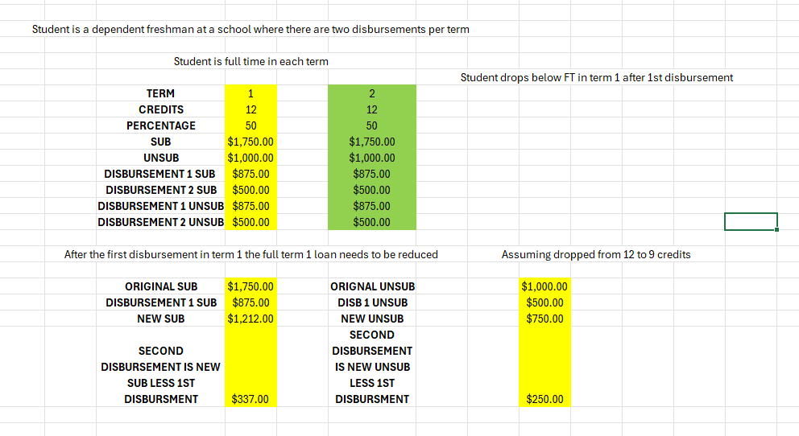

Question 5
Can you give an example of 3 terms (Summer 6 cr., Fall 9cr., and Spring 9cr.) Graduate student
Answer:

I am assuming this is a quarter school or your summer is a header for which the credits are added to the Fall. I am also assuming that 6 credits is part-time and 9 credits is full-time.
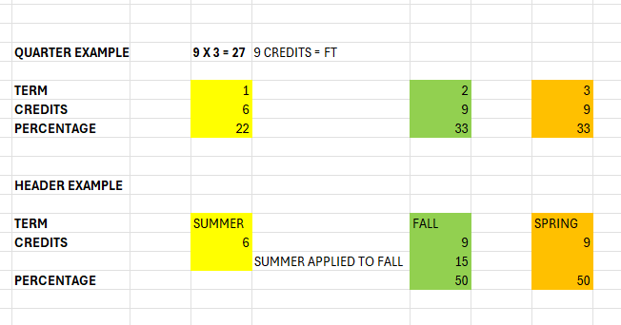

Question 6
if a graduate student borrowed a direct unsubsidized loan in 25-26, are they able to borrow Graduate PLUS loan in 26-27 (if they are enrolled in same program for 26-27)?
Answer:
Yes, assuming that they meet the other requirements of the interim exception – please see my slide deck. Also, remember, the interim exception is one thing we know the department has to rethink.

Question 7
in Example 10, you are reducing the COA to 66% of the total and then reducing grad plus eligiblity again down to 66%? Wouldn't only one of those be reduced? Slide 46
Answer:
No. It is accurate on the slide.
First you must reduce the COA to obtain the base Grad PLUS. COA – OTHER FINANCIAL AID is the base.
Then you must reduce the base loan.
For convenience, of example, I used the same percentage for reducing the COA as I did the loan. That may not be the case at your institution.

Question 8
For Example 10, term 1 has the student at 6 credits but also says NE (not eligible). Is this an error on the slide?
Answer:
I don’t have NE for 6 credits on the slide. It is 66% of the term eligibility (please remember for Grad PLUS I switch to term eligibility vs. award year eligibility to make sense of it)

Question 9
Does 6 credits for grads equal 66 or 50%
Answer:
Good question. I struggled with this one myself. You have to remember that reduction is based on credits not half time (50% is what you are thinking). I understand the confusion. If 9 credits is FT then it is 9 x 2 = 18. Then 6/18 = 33% for the award year. That example I switched to term eligibility, so 6/9 = 66%, which is accurate.

Question 10
Slide 35 - Example 5 (or any other with extra eligibility moving from term 1 to term 2), this assumes the student is at the same school both terms. If this student was to transfer between terms 1 and 2, can school 2 use the extra eligibility from term 1 at another institution?
Answer:

Very good question, and one of many things I did not cover for lack of time. The department advised that we are not responsible for knowing what happened at a previous institution. I was concerned that we may need to reduce in term 2, given what happened in term 1 at another institution. I was advised that this would not be the case.

Question 11
Remaining period of program - one term - student take 15 credits. We can still use 15/24 percentage? I thought I saw/heard, the loan eligiblility for remaining period of program - one term - can't be more than 50% of the annual loan amount.
Answer:
I did not cover historical loan proration, which is what you are referring to. To my knowledge, nothing for historical loan proration has changed.

Question 12
What about masters programs that are part-time every semester - two year program 6 credits each semester? Does that program need to be held to the full time standard anyway if the total for that program is 6 credits - half time and never would be expected to take 9 credits?
Answer:
The loan reduction would be 6/9 or for the award period 12/18.

Question 13
Would spring withdraws impact summer?
Answer:
If Summer starts a new award period, no.

Question 14
General Question – we have programs where students can choose to attend in the summer, but it’s not required. Full time is also defined differently in the summer. How would this impact the proration calculation? Summer is our header.
Answer:
I would need to know a little more to answer this intelligently. If it is a header and the credits are applied to the upcoming award year, you can see my response to question 5.

Question 15
Clarification on R2T4 examples, if we don't adopt current term policy adjustment and the student drops before disbursement 1st term, do we need to adjust loan before R2T4?
Answer:
Yes.

Question 16
If student does not return for term 2 and college opts impact to not affect current term, do we need to go back and reduce?
Answer:
No.

Question 17
In the Graduate PLUS loan example provided the Graduate student was looked at by semester instead of by BBAY. For the SOR of a Grad PLUS it makes sense to do by single semester, however, I want to confirm that we can do single semester for graduate students because for term 1 the Unsub was reduced based on the 66%. Is this even if the reduction happens after disbursement? I'm not sure if that would be a school policy or if we are mandated to make the adjustment in semester 2 (which is why i'm asking about the Graduate PLUS example).
Answer:
I used the term example to make sense out of it, however, the full award year relationship still exists.

Question 18
to clarify (sorry my question is a lot): if the student has 10250 for fall, drops after disbursement, could we reduce the unsub at that time too OR is it just reduced for calculation of Grad PLUS purposes
Answer:
Laon reduction applies to both the unsub and Grad PLUS.

Question 19
When do you recommend we review for scheduled reductions? Would a best practice be to review for drops/withdrawals prior to disbursement and then again once the withdrawal period ends?
Answer:

We can discuss institutional policy, however, remember that we have always been required to check for eligibility prior to disbursement this is not knew. What is knew is that you are no longer checking for SAP, verification etc. No loan reduction applies.
And yes, at the end of the term (or sooner) you need to see the end result of term 1 and how it might impact term 2.

Question 20
Based on current understanding, if an institution has a non-standard summer term (2 semester aid year) that is a header, would packaging a loan for the summer term require a reduction of fall eligibility to prevent using more than 50% by the end of the fall term? Or is there some other limit that must be imposed on the summer term?
Answer:
To my knowledge, these new rules do not apply to non-standard terms. You should do everything you have always done.

Question 21
For the provided calculator that was emailed to us: first of all, this is fantastic! I do have a few recommendations; can you please add to your program dropdown an option for professional programs with the $50,000 unsub prepopulated? Can you include Grad PLUS loans too? Also include more terms for trimesters or quarters. That would be very helpful. Thank you!
Answer:
Thank you for the compliment on the calculator. I would be more than happy to help you edit it so that it works for your institution.

Question 22
Will we still be using the old pro-ration calcuation for students graduating in summer or fall? Sometimes they were over 12 credits and received higher loan eligilbity.
Answer:
To my knowledge, this rule has not changed.

Question 23
Is there any specific guidance for Community Colleges - we have students who do not register for both FA & SP
Answer:
As mention during the webinar, the department has yet to provide guidance for schools that register one term at a time – hang in there.

Question 24
My question is going forward. Not Summer 2026 - if stu drops class after disbursement so no adjust is needed and it’s Summer term (our school has 3 full 15-week terms per year), then they return for Fall but do not have a FAFSA on file so ineligible for aid? How do you handle loan ineligiblility?
Answer:
I need a bit more information. I am very familiar with 3 semester environments. We should discuss.

Question 25
slide 66: why is unsub only 3500 should'nt it be 5500 as student is a senior?
Answer:
This example is addressing a student approaching aggregate limit (unless we are discussing 2 different slides). There is sub of $500.

Question 26
When add credits to term two for term school because term 1 is less than 12 credits how do you add it to loan in term 2? Can you just add amount even if it greater than the usual 50% of say a 3500 sub loan or does have be separate loan in term 2?
Answer:
Yes, term two can be greater than 50%. It is term one that cannot be.

Question 27
If you don't require summer attendance how would that effect the schedule of reduction for fall/spring?
Answer:

It depends on how you handle summer now.

Question 28
If a student goes from 12 to 9 credits in Fall, but is not yet registered for Spring, would we then be required to reduce the Fall loan? Can we wait until the College opens Spring registration to decide if we reduce Fall or Spring?
Answer:
It depends upon whether the loan was disbursed or not.
- If disbursed, you need not reduce the term 1 loan but you would have to reduce term 2 if the student does not register for 15+ credits.
- If before disbursement, the term l loan would have to be reduced unless the student adds a credit in a module or adds to greater than 24 total credits for the award year. The term 2 can have a greater than 50% loan.

Question 29
Your slides show you reducing the sub and unsub amounts by the same percentage, but I have seen nothing about the sub eligibility being changed, only the total loan eligibility. Wouldn't the reduction be taken fully from the unsub if possible, before touching the sub amount?
Answer:
No, loan reduction applies to sub and unsub equally.

Question 30
Fall student, registered full-time, does a complete withdrawal AFTER the 60% point. No R2T4 is required. Do we need to prorate Spring loans?
Answer:
First a correction. You must still do the R2T4 calculation even if it results in 100% retention of aid.
If the student returns in term two, it stands alone (again, this can change, but that is my current understanding)

Question 31
Summer is our header. Students are enrolled for 6 credits for the summer. Will we need to calculate the schedule of reduction for the summer, if the student is going to enroll for 12 credits in the Fall 2026 and 12 credits in the Spring 2027?
Answer:
I think my earlier example (Q5) responds to this question.

Question 32
Does change in program refer to the degree or major? So if a student changes major, will the be legacied?
Answer:
Yes, if a student changes program, level of study or take a leave from the school, the interim exception (as it is currently understood) no longer applies.

Question 33
If we originate a freshman loan prior to July 1, do they go under the new rules.
Answer:
The origination date is not relevant. The relevant point is any loans made on the 25-26 ISIR do not require reduction. It is effective on loans made from 26-27 ISIRs and forward

Question 34
I was at the FSA conference. A drop was no record on the transcript and a withdrawal was later in the semester. Tammy did say if we considered a withdrawal still full-time we did not need to adjust like we would for dropped classes.
Answer:
This is not my understanding. You may be still charging full time but they are not registered full time by the end of the term and thus loan reduction applies.

Question 35
From NASFA: Tamy Abernathy, director of ED’s Office of Postsecondary Education policy coordination group, said that these adjustments always rely upon the institution’s definition of full-time status. As such, if an institution considered a student to still be full-time at the end of the fall term based on a grade of W, I, or F, then the financial aid administrator would base annual loan eligibility on full-time enrollment for fall. Previously, the department has not been clear about whether and how W, I, F are different from drops during add/drop
Answer:
Again, we are not in agreement, so let’s wait for written guidance.
QUESTION SUBMITTED TO ME BY EMAIL
Question 35
For a student who goes from undergraduate to graduate (i.e. graduates with their undergraduate degree in May 2026 and then begins a graduate program in September 2026), are they grandfathered in for the exception if they had direct loans as an undergraduate, or does the fact that they are changing programs override the exception since the grad program is different from their undergrad one? Related to this, if they are grandfathered in, would they be eligible for a Grad PLUS loan, even though they obviously wouldn't have had that as an undergrad, but if they did have direct sub and/or unsub loan(s) as an undergrad? Any help you can provide would be greatly appreciated.

Answer:
Sorry, It is my understanding that this student would not be eligible for the interim exception because they are no longer in the same program or level of study.

Question 36

Last term of the Associate degree program. Student goes 15 semester credits. (Your basic one term loan - last term of the program.) AY = 24 semester credits.

Sub loan annual loan amount = $4500

15/24 x $4500 = 2813

I thought I heard that it can't be more than $2250, is that true? No more than 1/2 the Annual loan amount.

What about if the last 2 terms of the associate degree program the student attends 15 credits : 9 and 6 accordingly. Currently we would calculate it as 15/24 x $4500 and divide equally.

How would you calculate the loan disbursements under the new regulations?

Answer:
Under old regulations, original proration, it could go over 50%. I have not heard that his has changed.
Proration applies to the entire remaining period of study
When a student will graduate in less than an academic year, the annual loan limit must be prorated based on the hours the student will take in the remaining period compared to the hours in the school’s Title IV academic year.
Example :
- Academic year = 24 credits
- Remaining to graduate = 15 credits
- Proration fraction = 15 / 24 = 0.625
This fraction is applied to the annual loan limit to determine the maximum loan for the entire remaining period.

As to your second question, I believe the new loan reduction rules would apply so it would be 9/24 + 6/24

