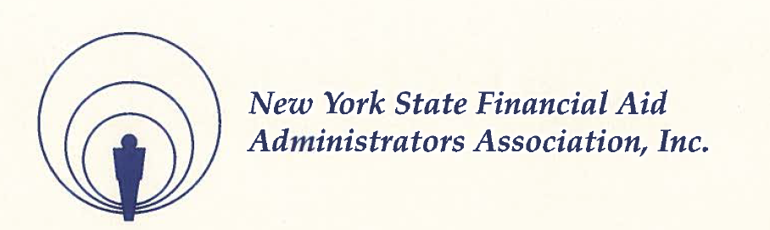

NYSFAAA Annual Business Meeting
October 31, 2019

2018-2019 Executive Council
Howard Leslie – President – Berkeley College
Darrin Rooker – President Elect – New York Chiropractic Colle
Adrienne King – First Vice President – Bank Street College of Education
Brian Smith – Second Vice President – SUNY – Cobleskill
Susan Godreau – Treasurer – SUNY – Potsdam
Anne Sullivan Polino – Secretary – Bryant & Stratton College
Kathy Michalski – Region I – Niagara County Community College
Shalena Clary – Region II – University of Rochester
Patti Donahue – Region III – Binghamton University
Randi Moore – Region IV – Samaritan Hospital School of Nursing
Joseph Weglarz – Region V – Marist College
Ajana Wilkinson – Region VI – Kingsborough Community College
Debra Evans – Region VII – Adelphi University
Stacey Hawkins – Region VIII – Clarkson University
Lisa Simpson – HESC Liaison

2019-2020 Executive Council
Howard Leslie – President – Berkeley College
Adrienne King – President Elect – Bank Street College of Education
Debra Evans – First Vice President – Adelphi University
Brian Smith – Second Vice President – SUNY – Cobleskill
Susan Godreau – Treasurer – SUNY – Potsdam
Shalena Clary – Treasurer Elect – Corning Community College
Anne Sullivan Polino – Secretary – Bryant & Stratton College
Lea Nuwer – Region I – Buffalo State College
B.J. Revill – Region II – University of Rochester
Patti Donahue – Region III – Binghamton University
Rochelle Filler – Region IV – Rensselaer Polytechnic Institute
Joseph Weglarz – Region V – Marist College
Michelle Bolton – Region VI – CUNY School of Medicine
Clair Jacobi – Region VII – New York Institute of Technology College of Osteopathic Medicine
Stacey Hawkins – Region VIII – Clarkson University
Lisa Simpson – HESC Liaison

Howard Leslie called the annual NYSFAAA 51st Annual Business Meeting to order at 8:14 a.m.

Howard began by thanking the Conference Committee for their work on putting together a successful event.

Approval of the 2018 Minutes – The minutes were posted to the NYSFAAA website.

Howard Leslie asked for a motion to waive reading the Minutes. A motion was made by Perry Brown and seconded by Randi Moore to suspend the reading of and approve the minutes. A vote was taken with all in favor, no opposition and no abstentions.

Treasurer’s Report - Rob Zasso presented the Treasurer’s report
Account | Amount | Notes
Key Bank Checking Account | $224,172.01 | As of 10/22/2018
Key Bank Scholarship Account | $29,579.44 | As of 10/22/2018
Key Bank CD | $52,446.12 | As of 10/22/2018
Morgan Stanley TRAK | $329,442.24 | As of 10/22/2018
Morgan Stanley TRAK Scholarship | $248,207.78 | As of 10/22/2018

Account Balances as of October 22, 2019

A motion was made by Adrienne King and seconded by Randi Moore to accept the Treasurer’s Report with all in favor, no opposition and no abstentions.

Rob Zasso reported that NYSFAAA’s investment accounts continue to be strong with the investments in the Scholarship fund being well managed by Morgan Stanley. The 2017 Audit is still in progress and is expected to be completed soon. Once the 2017 audit is done, the 2018 audit will begin.

Rob also reviewed the 2019/2020 NYSFAAA Budget.

Howard Leslie proposed a Constitutional change to require high school guidance counselors to pay for membership. It was noted that this proposal did not pass at the Executive Council level and requires a two—thirds vote of membership.

The discussion was tabled and with plans to review at a later date.

President Leslie also noted that the Strategic Plan is going well and is available on the NYSFAAA website for review. Howard encouraged involvement in the organization.

New Business

Lucy Villaquiran posed a question on the cost of membership by asking if the cost is too high for staff members.

Lucy would like the membership to consider a change in the membership fee structure utilizing a volume discount structure or a variable rate depending on professional level with staff members paying a lower level than more senior members. Both membership levels would receive the same benefits with perhaps a limit on voting rights.

President Leslie acknowledged the request and indicated that the proposal would be added to the Executive Council agenda for further discussion and review.

No additional business was discussed.

The meeting adjourned at 8:45 a.m. A motion was made by Adrienne King and seconded by Rob Zasso. A vote was taken with all in favor, no oppositions or abstentions.

Respectfully submitted.

Anne Sullivan Polino
NYSFAAA Secretary

