NYSFAAA

New York State Financial Aid Administrators Association, Inc.

2019-2020 Annual Report

President’s Remarks 2
NYSFAAA 2019-2020 Goals and Objectives 5
Awards Committee 9
2019 Conference Committee 10
Development (Fundraising) Committee 24
Mentor Committee 25
Elections Committee 27
Treasurer; Budget and Investment Committee 28
Governance & Ethics Committee 30
Government Relations Committee 31
Membership Committee 33
Novice Training 34
George Chin Memorial Scholarship Committee 36
School Outreach and Early Awareness Committee 37
Statewide Training Committee 39
Technology, Innovation, and Communication Committee 42
Regional Reports 43
Region 1 Report 44
Region 2 Report 46
Region 3 Report 48
Region 4 Report Error! Bookmark not defined.
Region 5 Report 50
Region 6 Report 51
Region 7 Report 52
Region 8 Report 53
Exhibits Error! Bookmark not defined.

President’s Remarks

NYSFAAA President
2019-20 Annual Report

I had a plan for the 2018-19 that went quickly off track when I received an email from ATAC, NYSFAAA’s website host, that they were going out of business at the end of October 2019 and would no longer be able to host our website. I/we made it through that – no problems. Who could have predicted what 19-20 turned into? A pandemic? Really?

In the early part of 19-20 I remained focused on our strategic plan, enhancing the website and advocacy. I think we did a great job with every aspect of what was important for NYSFAAA and our members. We were even able to start a new committee, referenced below, and complete a good percentage of the strategic plan.

My most important 19-20 goal, in my opinion, was to launch NASFAA Credential Training in NYS. We were all set to go, with Kerri Cooper at the helm, when February and March of 2020 brought mayhem to NYSFAAA, the country, to the world.

With everyone, now forced to work from home, students forced to go online and with a plethora of new statutes and guidance (changing regularly) I made it my mission to keep the membership informed and feeling supported. Having the new tools of our website, everything significant to COVID-19 was placed on the site making guidance easy to find. A one stop shop for everything FA COVID-19. Then Statewide Training, and our second VP, came up with the concept of open to the community COVID-19 support webinars. I did not jump on that at first but then realized the importance of that service, not only for NYS but also to the over 20 other states we provided important guidance and survival content to. I have never been more proud of being a member of NYSFAAA, offering seven, free to the community, webinars in a three-month period.

The other important thing I realized was it was my job to keep the community together. This included negotiating free additional GOTOMEETING licenses enabling me to provide virtual access to the regional and committee chairs. No one knew how long this pandemic would last – we still do not know. What I quickly recognized was the importance of continued regional meetings and committee activities. The unexpected benefit is that I have been able to attend regional meetings throughout this, from Florida, in this new virtual environment.

Finally, I started hosting virtual happy hours every Friday. These started out being well attended. After a while, I believe people became tired of it – so we stopped except for one last one celebrating the one-year anniversary of our new website. We held a nice party.

There will be another One Last Virtual Happy Hour on Friday October 30. That will be the final closure to our first ever Virtual Conference. Virtual Conference? Did I really have to be the first president to cancel novice training and our conference? I am told that I was where I was and when I was because it was fated to be. The most important thing, for me, is that we made it this far and we will continue to do that because we are

NYSFAAA STRONG
In closing, I want to wish Adrienne King, our incoming President, nothing but the best. I will be here to support her and NYSFAAA in any way I can. Next year and in any way I can after that.

2019-2020 Executive Council
Howard Leslie – President – Berkeley College
Adrienne King – President Elect – Bank Street College of Education
Debra Evans – First Vice President- Adelphi University
Brian Smith – Second Vice President – SUNY Agriculture & Technology at Cobleskill
Susan Godreau – Treasurer – SUNY Potsdam
Shalena Clary – Treasurer Elect– Corning Community College
Anne Sullivan-Polino– Secretary – Bryant and Stratton College
Lea Nuwer – Region I – SUNY, Buffalo State
B.J. Revill – Region 2 - University of Rochester - School of Medicine
Patti Donahue – Region III – Binghamton University
Rochelle Filler– Region IV – Rensselaer Polytechnic Institute
Joseph Weglarz – Region V –Marist College
Michelle Bolton – Region VI – Kingsborough Community College
Clair Jacobi - Region VII – New York Institute of Technology College of Osteopathic Medicine
Stacey M Hawkins - Region VIII – Clarkson University
Lisa Simpson – HESC Liaison

A President cannot function without an excellent Executive Council. I want to thank each one of them for supporting me as well as keeping me on the correct path. A big shout out for Susan and Anne. I know that the Treasurer and Secretary hold the two most difficult positions on Council. These two ladies have done a spectacular job.

I want to give another special recognition to Lisa Simpson – a longtime colleague and friend. Behind the scenes, she has been a true compass north for me.

Last year I provided details on all the committees’ efforts. That made this report longer than necessary, as each committee chair will be doing that reporting below.

This year I just want to recognize our new committee. Financial Literacy. Under the watch of Maximo Flint-Morgan, I expect NYSFAAA to offer more services, education, and awareness about this crucial portion of our field. I expect this will result in higher quality important services and information to our students as well as increase in NYSFAAA membership by attracting people who are not currently part of the team. I think Max will be working at supporting NYSFAAA at very high levels in the future. Thank you Max.

Goals and Objectives
• We have successfully completed a good portion of our strategic plan.
• We are NYSFAAA STRONG and we must remain so.

Upcoming Meetings and Events
• Executive Council Meeting Monday October 26th Virtual
• NYSFAAA’s 51st Conference October 28th – Virtual
• TBD by incoming President
Conclusion
As I said last year, a President is only as good/strong as his two teams – Executive Council and his Committee and Regional Chairs. I have been blessed for two years with great Council people and Chairs. I step down from my presidency wanting to accomplish more but satisfied with the work we have done together. I thank you all from the top and bottom of my heart.

Respectfully submitted,
Howard Leslie

NYSFAAA 2019-2020 Goals and Objectives

Awards Committee
Our goal for the 2020-2021 year is to increase nominations from the membership for the state-wide awards.
Our long term objective is to promote the major points of the NYSFAAA long range plan by highlighting the aims of the plan through our award ceremony at the annual conference. Ideally each year we will be recognizing awardees that are strong examples of advocacy, outreach, mentoring, & fostering a strong financial aid community.

Development (Fundraising) Committee
Identify other options for re-opening the NYSFAAA Novelties Store.

Mentor Committee
Request volunteers to serve on the committee from the Regions that do not have a member on the committee.
Periodically send requests to the membership to serve as Mentors and expand our Mentor list.
Encourage members to invite newer members to attend Regional meetings and State Wide training events.

Elections Committee
There shall be an Election of the next President & Treasurer. The Elections & Nominating Committee should be instituted by March 1st. The slate should be fixed before the end of April. The election must be completed by June 1st .

Treasurer; Budget Committee; Investment Committee
The primary short-term goal is the smooth transition from Treasurer-Elect to Treasurer and Treasurer to Past Treasurer. This process requires the transfer of accounts, administrative accesses as well as banking and credit card authority.
A medium-term goal is to explore alternative payment options for certain member schools that uses methods other than credit card and checks. The current pandemic created payment challenges for some of our members and electronic payment (ACH or direct deposit) was requested by a number of schools. A consistent secure payment and communication process will be explored.

Governance & Ethics Committee
There shall be an evaluation of the Best Practices from this committee. There is a concern that some items listed we might not be doing and that we haven’t added some items yet that should have been there long ago.

Government Relations Committee
With HESC leadership to establish an appropriate schedule for resuming NYSFAAA and HESC Quarterly Meetings.
Network with and directly collaborate with EASFAA and NASFAA in their Government Relations outreach efforts. Utilize NASFAA’s State Advocacy Toolkit resources.
Explore networking and collaboration opportunities with other NY State higher education professional associations, such as the NY State Association of College Admission Counseling.
Continue working to raise NYSFAAA’s profile amongst members of the NYS Senate & Assembly who serve on their respective Higher Education Committees – with the goal of presenting & positioning NYSFAAA as an expert resource and sounding board for proposed student aid legislation.
Continue to actively monitor proposed and passed NYS and Federal financial aid and higher education legislation (including Reauthorization proposals), with the goal of preparing comments, feedback, and where appropriate letters of support/endorsement of such legislation for approval and dissemination by the Executive Council and NYSFAAA President respectively.
Organize and lead NYSFAAA’s participation in the 2021 Student Aid Alliance Advocacy Program, which will likely consist of virtual advocacy efforts. Review NYSFAAA’s State Aid proposals and make appropriate changes and/or updates.
Encourage & support members from each Region of NYSFAAA as well as members of the Government Relations Committee to participate in advocacy with their local elected officials – continuing to raise awareness of NYSFAAA online resources, the Association’s community outreach efforts (i.e. FAFSA & TAP Webinar), and to promote support for NYSFAAA’s State Aid Proposals.
Continue to strengthen the function and activity of the Government Relations Committee, working to recruit additional members and to further solidify regular meetings and committee members roles.

Membership Committee
Reach out to the Directors to find out why their Members and Novices do not attend meetings.
Brainstorm and hold virtual Networking Sessions for members.

Novice Training
The primary goal of Novice is to provide financial aid training and networking for those who are new to the profession, as well as other personnel that work with financial aid. Novice typically consists of five days of intense training with alternating sessions between Large Group Lectures and Small Group breakout sessions. Group interaction is encouraged within small and large group as well as the Novice Olympics.
As the world continues to grapple with the “new normal”, and schools are facing challenging economic climates with limited professional development budgets, the primary goal for 2020-2021 is to offer Novice Training, even if it means the program is offered in a reimagined format.

George Chin Memorial Scholarship Committee
Crystal Krudis and Janice Hilbrink are to fully transition as co-chairs of the committee. The committee will continue to investigate any additional sources of funding for the scholarship fund and seek scholarship donations throughout the year- a bit more limited during COVID-19. Fundraising will take place virtually this year. The website was updated to allow for the online purchase of raffle and 50/50 tickets. Regions will donate a physical or electronic gift card, which we will be raffle off during the virtual conference in October 2020.

School Outreach and Early Awareness Committee
Develop and continue to offer college aid workshops and events to students and their families as well as school counselors
Work on additional ways to better communicate with students/families during Pandemic
Network with communities and their officials to promote FAFSA filing opportunities and look to re-brand our events
Investigate better uses for technology to further our mission
Push out more communication to recruit more NYSFAAA members to be involved…(i.e. reach out to campus directors)

Statewide Training Committee
FALL 2020

DATE TBD – Verification Training
Presenter: Joellen Soucier

September 24 – Having Fun with Taxes-part 1
Presenter: Robert Weinerman

October 2 – 2021/2022 FAFSA and TAP Application Training Annual Community Webinar
Presenter: LaSonya Griggs & Michael Tuner

October 8 – Having Fun with Taxes-part 2
Presenter: Robert Weinerman

October 1 – Clock Hour Training-part 1
Presenter: Gregory Rinderle

October 14 – Clock Hour Training-part 1
Presenter: Gregory Rinderle

October 15 – Clock Hour Training-part 2
Presenter: Gregory Rinderle

October 28 – NYSFAAA Virtual Conference

November 13 – Mindfulness in the Workplace
Presenter: Lucinda Snyder

Technology, Innovation, and Communication Committee
Continue updates and improvements on the NYSFAAA website
Encourage posting of minutes
Determine needs of the membership
Provide website training where needs are identified
Continue support of the Statewide Training Committee with surveys
Identify new technologies that benefit NYSFAAA and its members
Maintain social media presence
Continuous updates to BOT knowledge

Awards Committee
Committee Members:
Dan Robinson | Co-Chair
Robert Zasso | Co-Chair
Mary Koehneke | Region I
Susan Romano | Region II
Dawn Langdon | Region III
Brian Smith | Region IV
Scott Khare | Region V
Wayne Harewood | Region VI
Debra Evans | Region VII
Kerrie Cooper | Region VIII

Summary of Activities for 2019-2020:
The NYSFAAA Awards Committee continues to enjoy its work. The Committee is currently in the process of collecting nominations, printing plaques and programs for the 2020 awards. At the 2019 conference our members received one Achievement Award, two General Service Awards, two Citations of Appreciation, the Mr. Thomas Monahan Service Award, NYSFAAA Founders Service Award, Sister Bernadine Hayes and Rusty Hopkins Service Award, two Special Lifetime Achievement Recognition Awards.

At the beginning of the 2019-2020-year Troy Martin stepped down as Co-Chair and Dan Robinson agreed to step in as Co-Chair. We also completed the changeover that started in 2018-2019 from all plaques to a variety shaped glass and wooden plaque awards for the different types of recognition bestowed upon our members.

Goals and Objectives for 2019-2020:
Our goal for the 2020-2021 year is to increase nominations from the membership for the state-wide awards.
Our long term objective is to promote the major points of the NYSFAAA long range plan by highlighting the aims of the plan through our award ceremony at the annual conference. Ideally each year we will be recognizing awardees that are strong examples of advocacy, outreach, mentoring, & fostering a strong financial aid community.

Future Meetings and Events:
Our next meeting will be at the 2020 NYSFAAA Conference and then the next planned conference call will be in Summer 2021.

Submitted By: Dan Robinson & Robert Zasso, Awards Committee Co-Chairs
Date: 09/18/2020

2019 Conference Committee

NYSFAAA 51st Annual Conference Report
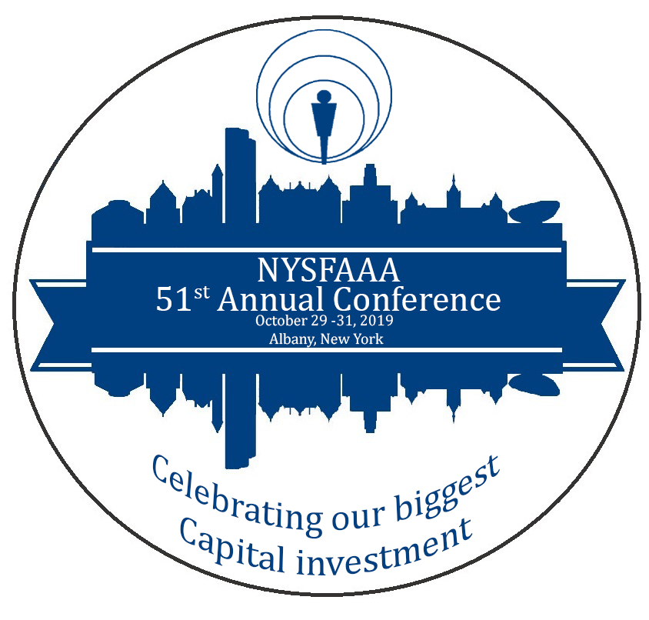

“Celebrating our biggest Capital investment”
Hosted by Region 5 at the Albany Marriott
October 29- 31, 2019
Albany, NY

Co-Chair Report:

Lisa Simpson and Joe Weglarz

The 51st Annual NYSFAAA Conference was held at the Albany Marriott, Wolf Rd. Albany, NY from Tuesday, October 29, 2019 – Thursday, October 31, 2019. A preconference training was held on Monday, October 28, 2019. It was the first time the conference was held in this location. The conference was sponsored by Region 5 but after a search of hotels in that region, the group decided that the Albany area (region 4) would serve as a better location with more reasonable hotel options and more centrally located.

Requests for information to six hotels in the Albany area provided the conference committee with some options in selecting the hotel location. Proposals from hotels in Lake George, Saratoga, and Albany were received and the Albany Marriott was chosen based on cost and dates available. Selecting dates in October 2019 was difficult as there was a holiday every week in October except for the last week. To accommodate as many in NYSFAAA as possible October 28-31, 2019 was set as the conference dates.

The final conference registration included 235 participants and 31 vendor booths. The attendance was slightly less than our targeted enrollment of 250. We projected 26 vendors so were happy that the actual number exceeded this. This is in part is due to the good work of the vendor committee.

The goal of the conference was to provide strong informative sessions as well as to allow time for colleagues to network. The enthusiasm and dedication of the Region 5 Conference Committee definitely accomplished these objectives. The conference provided federal and state updates, strong keynote-speakers who are leaders in our industry, current, in-demand training topics, and professional networking opportunities. We felt the conference was a great success with 116 participants completing a satisfaction survey. 84% of the respondents rated the overall conference very good to excellent. Over 74% rated the Albany Marriott facilities from very good to excellent and over 92% rated their overall experience in Albany good to excellent.

To encourage early registration, the conference committee provided an early bird special for those who completed a full registration by September 15, 2019. A total of 138 people took advantage of the $35 discount. We had hoped this would allow for more people to be able to attend the conference but this did not increase our overall registration.

Conference Committees

Conference Co-Chairs: Lisa Simpson, HESC
Joe Weglarz, Marist College

Entertainment Chair: Mary Lou Kutchma, Marist

Facilities Chairs: Tom Dalton, Edamerica
Lisa Simpson, HESC

Program Chairs: Cindy Garvey, St. Thomas Aquinas College
Joe Weglarz, Marist College

Publicity Chair: Stephanie Stock, Sallie Mae

Technology Chair: Rob Zasso, Dutchess Community College

Vendor Chairs: Keith Babich, CommonBond
Jen Trauman, College Ave Student Loans

Challenges:

The largest challenge was getting volunteers for committees and finding time to meet. Since the conference venue was about a two-hour drive for some in the region the majority of the meetings for planning were held in the region. This allowed for those who were interested participating in a committee to come to the meetings held closer to their schools. We did have three onsite meetings to tour the facility and work on logistics.

In addition, the timing of the new NYSFAAA website created a few issues and a learning curve for both the conference committee and registrants. The move to the new website occurred at the time when the registration for the conference was being built and we needed to rely on those who were building the site. We worked through the issues, but we feel the process would have run smoother if the timing were different.

General Recommendations:

Secure speakers as early as possible, particularly the key note speakers and general session speakers. We were lucky to have a strong program committee and they got their speaker commitments early.

Preconference events- there was some confusion on who was responsible for any preconference training. The conference committee was under the impression that the statewide training committee would handle it, but it turned out the conference committee needed to set up the training. We suggest that you determine who will handle it and what the topic is early to allow time to find a presenter.

We had numerous registrants with dietary restrictions, so it is important to ask the question about dietary needs on the registration form and work with the hotel to accommodate all.

There was a last minute request for a memorial of those NYSFAAA members we lost during the year. The committee worked with the executive council to provide the appropriate remembrance. This should be incorporated as part of the facilities function if it is to be done on a yearly basis.

Conference Budget
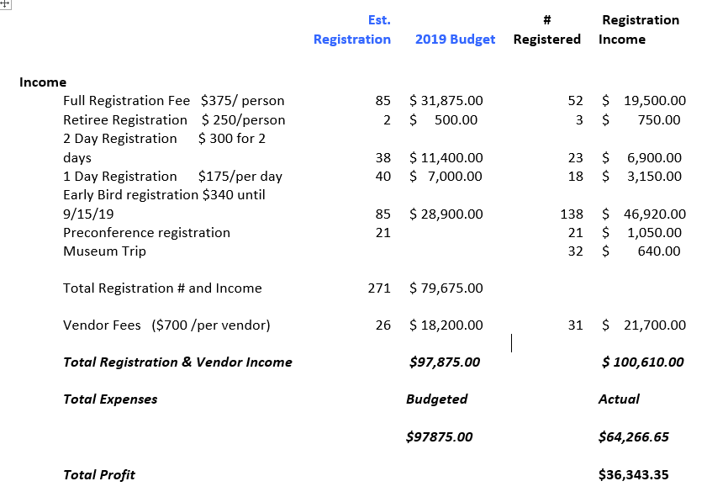

Breakdown of expenses:

Conference Committee (vests, memorial table, thank you items) $ 1,165.78
Facilities (food, beverage, meeting space rental) $45,709.28
Technology (audio/visual) $ 6,195.04
Program (speakers, preconference, bags) $ 4,923.96
Registration (lanyards, program, ribbons) $ 283.50
Publicity No costs
Entertainment (trivia, drink tickets, music, bingo, museum) $5,449.93
Vendor (table, gifts, raffle) $ 539.16

Program Committiee
Program Committee Final Report
Chair: Cindy Garvey and Joe Weglarz
Items to Review - Pre-Conference, Keynote Speaker, Federal and State Updates, NASFAA and EASFAA presentations, Presidents’ welcome and Concurrent Sessions
Composition of Long Program:
- Pre-Conference- Committee decided to offer a NASFAA training Module.
- Keynote- The keynote speaker opened the conference on October 29 at 10AM and was outstanding. Erin Gruwell (was AMAZING!) a BIG thanks to Janice Hilbrink from Pace for all her hard work on setting this up.
- President’s welcome/NASFAA update took place on Tuesday.
- Federal update was during breakfast on October 30 and awards were presented at lunch on Wednesday. Federal updates were given by Zachary Goodwin, Mary Lou and Lisa made contact.
- NASFAA update by Karen McCarthy, contacted by Lisa. EASFAA update by Marie Johnson.
- HESC update by Christopher Fernando
- Request/Call for Presentations and Presenters - we sent out an email with a form for members to complete if they had an idea for a presentation. We collected 59 forms. 35 sessions were offered, 4 concurrent sessions per time slot.
- The committee met and reviewed all submittals. We also added a leadership and mentor track.
- Monday’s evening’s receptionist at the NYS museum was a fun and education event. Attendance was 20.
- Confirmation emails were sent to all presenters. We requested a final PowerPoint presentation to be sent to us by September for final approval. Rob and I sent presentation template.
- Emails were sent to membership for volunteers to moderate sessions.
- Agenda was finalized and added to the mini site.
Pocket Program:
- Program was condensed to create mini folded programs. Thanks to Lisa and Diane for creating the pocket program. 300 pocket programs were printed.
- Pouches/bags were created and filled with Albany map, vendor activity and pocket program.
Presenter Gifts:
- Presenter and moderator gifts were completed by the entertainment committee.
Summary:
As a committee we collected as many presentations as we could. We sent several emails to the list-serv to presentations. The agenda for the conference was well received and survey comments indicated that topics covered were good. We covered the basics with our usual presentations, i.e. FAFSA, Taxes, and Verification. Based on evaluation comments we see that members enjoyed the leadership/mentor track. The program was very well thought out and there was a good flow of the sessions. A session on the Excelsior program was suggested. The agenda committee made sure that we had presenters representing Private, Public, 4 year and 2 year schools. The conference concluded on October 31 with the NYSFAA Business meeting and a HESC update at 10. Several comments about the conference ending on Halloween were received. The conference committee felt Halloween did not have a factor in attendance.

Facilities Committie
Tom Dalton and Lisa Simpson
As co-chairs of the facilities committee, we made approximately four trips to the hotel to negotiate and settle details. We met with them to discuss a possible discount in sleeping room pricing, review room scheduling, and find the best places for the vendor area and registration. On our first visit in the late winter, we received a copy of the menus, but didn’t select the food items until late spring/early summer.
When it was time for the final food counts, we adjusted down from the total conference count for the breaks and meals as we know that some folks will not attend all food events and will choose to eat on their own (particularly for the receptions). The vendor area was in the main hallway between the general session room and the breakout rooms to provide maximum traffic. The breaks and NYSFAAA raffles were in the vendor area as well as we felt it would help create more traffic for the vendors.

The conference committee decided to provide a few new and different ideas for the conference which included a visit from three therapy dogs. The therapy dogs were a big hit and they arrived for a two hour visit on Wednesday afternoon. Although we had a table set up for them, they walked around the vendor area and were available for pictures. Most everyone enjoyed the dog visits and taking selfies with them. We asked for a donation (not required) for the pictures and sent $140.00 to the Mohawk Hudson Humane Society.

We created menus with the hotel to meet all dietary needs as well as have variety at all meals. It was important to review the restrictions of some attendees to ensure there was ample food for all. We found that buffets at breakfast and lunch work best because of the time constraints. In addition, there are more choices to choose from.
Facilities also needed to work closely with registration, technology, entertainment, and program to make sure the agenda flowed smoothly, and all needs were accommodated. The conference committee determined that four concurrent sessions would work best for our size group.
This committee was responsible for the preconference setup and training. The training began at 10:30am and ended at 3:00pm. The training topic was the NASFAA Verification module and we provided lunch. There were 18 registrants for the training and the cost was $50.00 which included materials and lunch.

2019 NYSFAAA Conference Registration Report (as of December 16, 2019)

TOTALS: A total of 235 people registered for the conference:
- Full Conference - 191
- Two-day attendees – 23
- One-day attendees – 18
- Retirees – 3
- First-time attendees – 40
- NASFAA pre-conference attendees – 17
- Pre-conference Museum attendees – 28
Currently, there 6 unpaid registrations – multiple attempts have been made for payment:
- Full conference – 3
  - 1 was a no-show
- One-day – 2
  - 1 was a no-show
- President – 1 I think we need to find a way on the new website to have this fee waived or reflected as paid at time of registration

For the most part, Registration went well. A few more volunteers would have helped, but the Chair did not do additional outreach beyond Region 5. Recommendations are listed below.

We would like to thank the following people for assisting at the registration table during this year’s conference:
Cindy Garvey – STAC, Perry Brown – College of Westchester, Janice Hilbrink – Pace University, Tami Gilbeaux – Inceptia, Roberta Daskin – Sarah Lawrence, Diane Donohue and Linda Embleton – SUNY New Paltz, Rob Zasso – Dutchess CC

Suggestions for future conferences:
- Have Registration chair and other conference members trained on Memberclicks website
- Set early-bird special pricing early in the planning process
- Keep Vendor registration separate
- Have payments sent directly to NYSFAAA Treasurer
- If possible, have registration table close to designated conference office space
- Make sure you have an Internet connection at the hotel for the registration desk to handle issues as they arise, record payments and late registrations
  - A wired connection to a printer in case a name tag needs to be printed
- Opening registration on Monday afternoon prevented a huge rush on Tuesday morning. We staffed the tables Monday 3-5; Tuesday 8-5 and Wednesday 8-4. On Tuesday, the Registration should remain open throughout lunch – about 20 people checked-in during that time
- Try to have name tags/lanyards ready to go at least 2 hours before Registration Table opens
- Have members staffing table know the ‘lay of the land’ – restroom locations, session times and locations, etc.

Entertainment Committiee
In addition to the Conference being very successful, the Entertainment for the conference proved to be extremely well received, enjoyable and also very successful.
The planning began as soon as the first planning meeting was held, and the committee was formed. We started out with a few more committee members, but there were 3 of us that basically handled all things related to entertainment, except for Lisa Simpson providing contact information, and input and direction as needed. Our first item was to secure a guest speaker, and we were fortunate enough to get Erin Gruwell, who was an exceptional, idealistic speaker that touched the entire room with her touching and very powerful stories.
After considering several Halloween/Fall thematic events, the following was part of the Entertainment Agenda:
10/28: A trip to the NY State Museum the night before the Conference officially began, which included free bus transportation (Marist College picking up the cost of the bus), and food at the museum, costing the attendees $20.
10/29: 5:00-6:15pm- We provided a free drink coupon for the President’s Reception and offered a “Taste of Albany” with fresh baked cider donuts and apple cider purchased from a local shop, Krause chocolates (local chocolate shop) and apples from a local apple orchard during the reception.
10/29: 8:00-9:00pm -In the evening we hosted “NYSFAAA” bingo and had a very good turnout, with prizes and giveaways.
10/29: 9:00-11:00pm- We provided music (by Joe Gorman) in the hotel bar area
and advertised “NYSFAAA’s signature drink”
10/30: We provided another free drink coupon, purchased fall themed centerpieces from Christmas Tree Shop for the reception centerpieces and made up questions for the table to “interact” and win the centerpiece (who has the most years in financial aid, who traveled the furthest, etc.).
10/30: We held “Trivia”, again at the bar/open area, and hired a local person, Stephen Murray. There were more people than we expected, and they all created teams to compete against each other for prizes! This was very interactive, engaging and enjoyable. Free popcorn was provided, which was such a nice treat.
I believe that the Entertainment Committee was able to provide some innovative and interactive events for the conference, and managed to stay within budget.
Although it was planned with the entire committee, having Therapy Dogs come to the conference was truly a highlight, and the dogs were so very “entertaining” 😊

Respectfully submitted,
Mary Lou Kutchma

Publicity Committee Final Report
Chair: Stephanie Stock
Summary of Activities:
Theme: “NYSFAAA: Celebrating Our Biggest Capital Investment” was selected as the conference theme.
Teaser Gift: At the 2018 conference in Syracuse, attendees were given an “egg-timer” with the conference logo at the breakfast to represent the famous building in downtown Albany which is referred to as “The Egg”.
Publicity Blasts: A poster was displayed on an easel at the 2018 Conference registration table promoting the conference location and dates for the 2019 conference. Reminder postcards were also created and on display at the registration table. The very first promotion was a “save the date” sent in early February. The conference mini site was set up in mid- February (note that due to the migration from ATAC to MemberClicks this had to be redone in July). The mini-site was updated with access to all the required links. Call for session proposals, hotel information (name, address, conference room rate), registration (i.e., rates – highlight an early-bird registration discount if applicable), travel logistics (airport, train, & car directions), exhibitor information (vending fee & what that includes as well as booth set up and break down times) and a general mention of the NYSFAAA app and what to bring to the conference go up on the mini-site right away (See Appendix). As more conference details are added such as entertainment, charity, things to do, and general sessions and/or keynote presenter information becomes available, it is to be added to the conference mini-site. The program committee will loan PowerPoint presentation handouts to the NYSFAAA app and the conference mini-site as they become available. The links were updated as the information became available. Emails were sent to the listserv as information became available and/or links were updated/added.
The committee filmed two videos. The first promoted the pre-conference event at the NYS Museum and the second promoted the charity walk/run. Due to the multitude of emails that had been going across the listserv, it was deemed unnecessary to make any additional videos for fear of overwhelming the membership. Due to limitations of MemberClicks, any videos need to be emailed to Lea Nuwer who will put them on YouTube and send you the link which can be attached in the outbound emails. Videos were posted to the NYSFAAA YouTube, Facebook, and Twitter accounts.
NYSFAAA 2019 Conference Publicity Calendar
Completed | Time until conference | Action Date | Action Items *
☒ | 7 months | Mar 14, 2019 | - Save the date email  - Reminder that session proposals are due by Apr 12, 2019 – attached a copy of the session proposal form which was provided by the program committee chair.
☒ | 6 months | Apr 12, 2019 | - Announced Opening Keynote Speaker
☒ | 3 months | July 16, 2019 | - Registration and hotel reservation are open  - Highlight the early-bird discount for conference registration submitted by Sept 15th  - Those who register early were told they would be entered into a drawing for a free night’s stay at the Albany Marriott on some future date.  - Remind of the hotel room rate and no fee for parking
☒ | 2 months | Aug 2, 2019 | - Conference registration and pre-conference workshop reminder
☒ | 2 months | Aug 27, 2019 | - Early-bird registration cutoff of 9/15 reminder  - Added guided meditation link to support members during school opening
☒ | 1.75 months | Sept 5, 2019 | - 10 days left to lock in the conference registration discount
 | 1.75 months | Sept 5, 2019 | - Email president of SUNYFAP to request that the conference be promoted on the SUNYFAP listserv
☒ | 1.75 months | Sept 5, 2019 | - Email NYSFAAA region chairs to request that they promote the conference at their first fall meetings.  - Requested that they promote the location and dates and especially that the conference ends at 11 am on the 31st since there were concerns about it ending on Halloween. Also requested that they highlight the conference registration cost and that Zack Goodwin would be presenting multiple sessions.
☒ | 1 month | Sept 27, 2019 | - Email listserv regarding a New Department of Ed Session added on Fraud, Waste, and Abuse.
☒ | 1 month | Sept 30, 2019 | - Emailed listserv that the last day to reserve a hotel room at the conference discounted rate is October 10, 2019
☒ | 3 weeks | Oct 4, 2019 | - Last call reminder for the hotel room reservation deadline and final push for conference registration
☒ | 3 weeks | Oct 9, 2019 | - Another last push email to listserv to promote conference registration
☒ | 2 weeks | Oct 11, 2019 | - Emailed listserv to promote conference charity opportunity – a coat drive to support the homeless through the Capital City Rescue Mission
☒ | 2 weeks | Oct 14, 2019 | - Emailed first video to highlight the NYS Museum event on the Monday before the conference.
☐ | Post Conf | Nov 2, 2019 | - Thank you email & notice of presentations being available on website.

NYSFAAA YouTube, Facebook, and Twitter Contact: Lea Nuwer - nicholla@buffalostate.edu
Conference Minisite Contact: Ideta Daniel - ild1@cumc.columbia.edu
Budget: $50
Recommendations:
- Engage social media
- Create a NYSFAAA Instagram account
- Create videos to promote key sessions and pre-conference workshops
- As the conference is approaching, send at least one email per week.
- Access should be given to the Publicity chair to allow him/her to be able to format the emails in MemberClicks such that it is possible to change font size, color, and general formatting (e.g. bullet points, anchor text for links, etc.)
- Coordinate any email messaging that is going out to the general listserv with the various subcommittee chairs so that timing of messages makes sense and there isn’t a deluge of emails with competing messages.
(Additional information can be found in the Exhibit Section of this report.)

Technology Committee
Committee Members:
Robert Zasso, Dutchess Community College -Chair
Anthony Gabriel, Culinary Institute of America
Mark Schaeffer, Dutchess Community College
Christopher Earnshaw, Sallie Mae
Goals and Objectives:
Ensure all sessions were prepared with technology (microphones, projectors, computers -
general A/V needs)

Summary of Activities:
- Lisa Simpson worked with hotel staff to order technology needed for all sessions (general, breakout, gala event). This included all microphones, projectors and computer hookups.
- During conference, ran all sound and A/V for general sessions. Ensured all breakout sessions
were connected with A/V needs.
- Marist & Dutchess Community College provided 5 projectors and laptops to be used for presentations during the conference.
Recommendations:
- Have as many of the presentations before the conference so they can be printed or downloaded by the attendees prior to the start of the conference.

Vendor Committiee
Vendor Chairs: Jenn Trauman, College Ave Student Loans & Keith Babich, CommonBond

The Vendor Committee compiled a list of prospective vendors in April and composed a letter with high-level conference details at the same time. This email was sent to prospective vendors on May 1st but could have been sent a few weeks sooner. (See sample email below). We thought it was important to address early on the efforts that would be made improve traffic and attendee interaction with vendors.

We also initiated a new feature this year called “Beyond the Booth.” Vendors were asked to submit a few paragraphs about themselves personally and about the company they represent, along with a few pictures. Each week after Labor Day and leading up to the conference, the vendor chairs circulated a few vendor profiles to the NYSFAAA listserv in order to encourage registration and interaction with the vendor partners. This initiative was warmly welcomed by vendors and NYSFAAA membership and positive feedback was shared by both.

There were 31 registered vendors.
Ascent |  | iGrad
Campus Logic |  | Inceptia
Citizens |  | KHEAA
Cognition |  | McClintock Associates
College Ave |  | MEFA
CommonBond |  | Ocolot
Credible |  | PNC
Credit Union Student Choice |  | Sallie Mae
Discover |  | Scholarnet
Earnest |  | Sofi
ECMC |  | Thrivent
EdAmerica |  | Tuition Options
ELM |  | Ufi
Global Financial Solutions |  | VSAC
Highpoint Solutions |  | Wells Fargo

In addition to Beyond the Booth, there was a vendor game provided to all attendees. This year the game focused on the city of Albany. Each vendor was given the answer to a trivia question about the Albany skyline. While much effort was put into the game, there was a bit of confusion, as we had late vendor registrants. While a vendor game/activity is a good way to promote engagement, we would recommend keeping it very simple in the future.

The vendor fee included a 6-foot skirted table, 2 chairs and a waste basket (provided by CommonBond as the hotel did not provide). We did not allow vendors to choose their tables based on order of registration. That might be a consideration for future conference. Overall, most vendors were happy with the level of traffic, placement of the vendor area, and promotion of their collective sponsorship at the conference.

Additional Information is located in the Exhibit Section of this Report.

Development (Fundraising) Committee

Committee Name: Development Committee
Committee Members: Tami Gilbeaux, Dave Garelick & NYSFAAA President - Howard Leslie
Summary of Activities for 2019-2020: The NYSFAAA Novelties Store continued operations for a short time during 19-20. However, the Store received minimal orders and is now in a suspended status. The Store activity is attached.

Reviewed a proposal from Edunion, LLC. This proposal is to seek services from a consultant to identity new revenue streams and enhance current revenue channels. The proposal consideration, attached, is delayed due to the onset of COVID related activities.

Goals and Objectives for 2020-2021:

Identify other options for re-opening the NYSFAAA Novelties Store.

Future Meetings and Events:

To meet with Howard to discuss “NPR/PBS” model for NYSFAAA Novelties.

Submitted By: Tami Gilbeaux
Date: September 9, 2020

Mentor Committee

Committee Name: MENTORING COMMITTEE
Committee Members:
Co-Chairs: KERRY LUBOLD, SUNY PLATTSBURGH
NANCY TEODECKI, Retiree- SUNY UPSTATE MEDICAL UNIVERSITY
REGION 2: TAYLER KREUTTER, ROBERTS WESLEYAN COLLEGE
REGION 3: KEVIN SHULTS, SYRACUSE UNIVERSITY
REGION 6: WAYNE HAREWOOD, CUNY KINGSBOURGH COMMUNITY COLLEGE
REGION 7: AMY THOMPSON, ST. JOSEPH’S COLLEGE
REGION 8: KERRIE COOPER, SUNY COLLEGE OF TECHNOLOGY AT CANTON
Summary of Activities for 2019-2020:
- Mentor Check-in - The previous year we launched the mentor List on the NYSFAAA website. We completed a check-in with those mentors to see if any contacts had been made. We were pleased to hear back from several mentors that connections with mentees existed and positive interactions were occurring.

- 2019 Annual Conference- The Mentoring Committee worked in conjunction with the Conference and State Wide Training Committees to share our ideas for several ‘Professional Career Development’ sessions that would support new members and encourage mentoring activities. We helped publicize the conference by advertising the recommended sessions via the NYSFAAA list-serve.

- 1st Time Attendee Meet/Greet – Nancy Teodecki and several committee members reached out to new members at the conference attending as 1st time participants. After the conference we requested the ‘First Time Attendees’ list from a Conference Chair. A ‘Welcome’ message was sent to the attendees as an introduction to their committee representative, encouragement to attend meetings, become active in their region, and utilize the Mentor list as a resource.

- Committee Continuation – The Co-chairs reached out to the committee members asking their interest in remaining on the committee. All committee members agreed to continue to serve a second year and were actively supportive during the year.

- Mentoring in Regions – NYSFAAA’s regional chairs were contacted to encourage support of new members. The “Bring a New member/Colleague” to the SWT event outreach was well-received and several members took advantage of the suggested and encouraged regional participation.

- Mentorship - Mentorship was spotlighted in a podcast during the fall with Howard Leslie and Kerry Lubold. The discussion focused on helping each other, the wonders of our profession and how to be involved.

- New Members/Novice - The Mentoring Committee usually welcomes new members as part of the event materials at Novice and provides a gift. Given the cancellation of the 2020 Novice Training Workshop, the committee developed a ”Welcome to NYSFAAA” e-mail which was sent to 32 members who joined NYSFAAA in 2020. A copy of the list of members and message was also sent to Regional Chairs in order to notify them of new members in their region and that they may wish to extend their personal welcome/invitation to attend a regional meeting.

- Mentoring Reminder - We reminded the membership of mentoring opportunities by sending a list-serve announcement in May encouraging members to support each other and take advantage of the mentor search on the NYSFAAA website.
Goals and Objectives for 2020-2021:
- Request volunteers to serve on the committee from the Regions that do not have a member on the committee.

- Periodically send requests to the membership to serve as Mentors and expand our Mentor list.

- Encourage members to invite newer members to attend Regional meetings and State Wide training events.

Future Meetings and Events:
- Continue the ‘Welcome’ letter/gift for the graduates at the 2021 Novice Training Workshop.

Kerry and Nancy will be stepping down as Co-Chairs in October. Tayler Kreutter, who has served on the committee for several years, will be stepping up as Chair.

Submitted By:
Kerry Lubold, Co-Chair
Nancy Teodecki, Co-Chair

Date: September 9, 2020

Elections Committee

Committee Name: Elections & Nominations Committee
Committee Members:
Region 1 - Nicole Griffo, Hilbert College
Region 2 - B.J. Revill, U of R School of Medicine
Region 3 - Kevin Shults, Syracuse Univ.
Region 4 - Brian Smith, SUNY Cobleskill
Region 5 - Dan Robinson, Pace University
Region 6 - Michelle Bolton, CUNY School of Medicine
Region 7 - Gene Rogers, Molloy College
Region 8 - Carolyn Corcoran, SUNY Potsdam
Summary of Activities for 2019-2020:

The committee met via email to discuss the slate & sent out communication to the membership. There were 3 positions available: 1st Vice President, 2nd Vice President & Secretary. On May 26, 2020 the winners were announced:

Ms. Renee Swift-1st Vice President
Mr. Brian Smith-2nd Vice President
Ms. Anne Sullivan Polino-Secretary

Goals and Objectives for 2020-2021:

There shall be an Election of the next President & Treasurer. The Elections & Nominating Committee should be instituted by March 1st. The slate should be fixed before the end of April. The election must be completed by June 1st .

Future Meetings and Events:

They should be before the end of the year to see if any region wishes to change whom is representing them on the committee. Secondly, conversations regarding whom in their region is interested in the positions up for election should begin in all regions.

Submitted By: Adrienne R. King
Date: 9/28/2020

NYSFAAA Report Template 2018

Treasurer; Budget Committee; Investment Committee

Committee Members:
N/A
Summary of Activities for 2019-2020:
Thank you for a successful but unusual year. NYSFAAA continues to respond to both financial and situational challenges and opportunities. The budget was developed with care and deliberation to balance the organization’s mission and the current economic circumstances. Our accounts continue to be in good health. The Treasurer coordinated with the Treasurer-Elect and others as appropriate to develop and report on the 2020-2021 Budget, to provide current information on the overall financial condition and cash flow status of the organization and to review current NYSFAAA investments through virtual meetings. Robert Bell from Morgan Stanley has handled our investment accounts for a very long time and we are grateful for the guidance he provides.

Our committee activities this year continued to support the goals and objectives of NYSFAAA and our long-range plan.

The SFS Vendor portal was updated with the Treasurer’s information as Primary Contact. This will need to be updated during the Treasurer’s transition in the fall of 2020.

The Treasurer and Past Treasurer provided documentation for the 2018-2019 and 2019-2020 audit reviews. The 2018-2019 draft will be available in the next few weeks; progress on the 2019-2020 will be monitored for a timely conclusion.
Since the transition to MemberClicks, all payments are processed directly by the Treasurer; previously payments for membership and scholarship donations were sent to and processed by committee chairs. Troubleshooting any payment issues is now also usually managed or referred by the Treasurer.

Goals and Objectives for 2020-2021:
The primary short-term goal is the smooth transition from Treasurer-Elect to Treasurer and Treasurer to Past Treasurer. This process requires the transfer of accounts, administrative accesses as well as banking and credit card authority.

A medium-term goal is to explore alternative payment options for certain member schools that uses methods other than credit card and checks. The current pandemic created payment challenges for some of our members and electronic payment (ACH or direct deposit) was requested by a number of schools. A consistent secure payment and communication process will be explored.

Future Meetings and Events:
Treasurer-Elect Shalena Clary and I have met remotely to facilitate the transition of the Treasurer position. We will continue to meet and work together during this time of change. Thank you, Shalena!

Submitted By:
Susan Godreau, NYSFAAA Treasurer

Date:
September 23, 2020
NYSFAAA Report Template 2020

Governance & Ethics Committee

Committee Name: Governance & Ethics Committee
Committee Members:
Scott Atkinson - Emeritus, SUNY Brockport
Kerrie Cooper - SUNY College of Technology at Canton
Thomas Dalton - EdFinancial Services
LaSonya Griggs - Tompkins Cortland Community College
Heather McDonnell - Sarah Lawrence College
Darrin Rooker - New York Chiropractic College

Summary of Activities for 2019-2020:

The committee met via email to discuss the changes and the suggestion of changes to the 2017-2020 Strategic Plan & the Best Practices/Ongoing Activities and Strategic Plan.

Goals and Objectives for 2020-2021:

There shall be an evaluation of the Best Practices from this committee. There is a concern that some items listed we might not be doing and that we haven’t added some items yet that should have been there long ago.

Future Meetings and Events:

They should be determined by the Past President and Committee after the Virtual Conference.

Submitted By: Adrienne R. King
Date: 9/28/2020

Government Relations Committee

2019-2020 Committee Report
Committee Name: Government Relations
Committee Members:
Christopher E. Barto, LIM College, Chair
Clemente (Clem) LaPietra, Monroe College
Donna Gurnett, Association of Proprietary Colleges (APC)
Elaine Pimentel, CUNY Central Administration
Eileen Flood, J.D., St. John’s University
Frank Arce, Columbia University
Maria DeInnocentiis, Marymount Manhattan College
Susan Nesbitt Perez, Commission on Independent Colleges & Universities (CICU)
Thomas Kokis, Baruch College

Summary of Activities for 2019-2020:

Participated in an American Enterprise Institute (AEI) Meeting, co-presenting with Elsa Magee, Vice President of HESC, to their prestigious Future of American Higher Education group on “Free College Programs in New York” in November 2019. Also conducted an AEI Podcast for their program “The Report Card” on the same topic, which was selected as one of their top 5 podcasts of 2019 on this widely-listened to Washington, DC based education policy program. Was able to highlight some of the NYSFAAA 2018 State Aid Survey data & feedback from NYSFAAA members during these presentations.
- Conducted a December 2019 State Aid Advocacy Survey to NYSFAAA Membership requesting feedback & recommendations about how best to streamline the application process as well as administer TAP and other State Aid programs – received 159 responses with many detailed replies.
- Prepared FAFSA Act advocacy letter in support of proposed legislation (H.R. 2486) which would provide permanent funding for minority-serving institutions and allow direct data-sharing between the Department of Education and the IRS to streamline the FAFSA application process.
- Based on the results of the 2018 & 2019 State Aid Advocacy Surveys, prepared NYSFAAA’s 2020 State Aid Proposal recommendations:
  - Increase Maximum TAP Award & Expand Income Eligibility
  - Restore & Enhance Funding for Opportunity Programs
  - Eliminate the Inequality in Dependent & Independent Student TAP Awards
  - Align FAAs Use of Professional Judgment (PJ) for State Aid Programs to PJ for Federal Aid Programs
- Organized NYSFAAA’s participation in the February 11, 2020 Student Aid Alliance Advocacy Day, arranging visits by members of the Executive Council and the Government Relations Committee with key legislators and/or their staff members.
- Worked with NYSFAAA President to also organize a February 11, 2020 meeting with HESC VP Elsa Magee to present the results of the NYSFAAA State Aid Surveys from 2018 & 2019. This first meeting between NYSFAAA & HESC led to an agreement to have Quarterly touch base meetings to assist with communication & collaborations. These meetings have been on hiatus because of the pandemic.
- Participated in NYSFAAA Podcasts on the Federal Borrower Defense to Repayment (BDR) rules and the CARES Act HEERF program.
- Added Legislative Update links to the NYSFAAA homepage, with NASFAA’s federal legislative tracker and a NY State higher education legislation scanner.

Goals and Objectives for 2020-2021:

- With HESC leadership to establish an appropriate schedule for resuming NYSFAAA and HESC Quarterly Meetings.
- Network with and directly collaborate with EASFAA and NASFAA in their Government Relations outreach efforts. Utilize NASFAA’s State Advocacy Toolkit resources.
- Explore networking and collaboration opportunities with other NY State higher education professional associations, such as the NY State Association of College Admission Counseling.
- Continue working to raise NYSFAAA’s profile amongst members of the NYS Senate & Assembly who serve on their respective Higher Education Committees – with the goal of presenting & positioning NYSFAAA as an expert resource and sounding board for proposed student aid legislation.
- Continue to actively monitor proposed and passed NYS and Federal financial aid and higher education legislation (including Reauthorization proposals), with the goal of preparing comments, feedback, and where appropriate letters of support/endorsement of such legislation for approval and dissemination by the Executive Council and NYSFAAA President respectively.
- Organize and lead NYSFAAA’s participation in the 2021 Student Aid Alliance Advocacy Program, which will likely consist of virtual advocacy efforts. Review NYSFAAA’s State Aid proposals and make appropriate changes and/or updates.
- Encourage & support members from each Region of NYSFAAA as well as members of the Government Relations Committee to participate in advocacy with their local elected officials – continuing to raise awareness of NYSFAAA online resources, the Association’s community outreach efforts (i.e. FAFSA & TAP Webinar), and to promote support for NYSFAAA’s State Aid Proposals.
- Continue to strengthen the function and activity of the Government Relations Committee, working to recruit additional members and to further solidify regular meetings and committee members roles.

Future Meetings and Events:

- Schedule monthly meetings for October & November 2020 and bi-weekly meetings in December 2020 & January 2021. Resume monthly meetings in February 2021.
- Participate in NYSFAAA’s virtual 52nd Annual Conference on October 28, 2020.
- 2021 Student Aid Alliance Annual Advocacy Program – tentatively in February 2021.

Submitted By: Christopher E. Barto
Date: September 27, 2020

Membership Committee
NYSFAAA Membership Chair Lucila Villaquiran
NYSFAAA Regional Representative s:
Region 1 | Marianne Loper, marianne.loper@houghton.edu
Region 2 | Katelyn Typhair, ktyphair@brockport.edu
Region 3 | Kevin Shults, k.j.shults@sunyocc.edu
Region 4
Region 5 | Joe Weglarz, Joe.Weglarz@marist.edu
Region 6
Region 7 | Patricia Noren, patricia.noren@ncc.edu
Region 8 | Patricia Farmer, pfarmer@stlawu.edu
Summary of Activities for 2019-2020:

• Added new organizations, colleges etc. to the database.
• Added new members to the database.
• Supported other NYSFAAA Committees as needed

Goals and Objectives for 2020-2021

• Reach out to the Directors to find out why their Members and Novices do not attend meetings.
• Brainstorm and hold virtual Networking Sessions for members.

Future Meetings and Events:

• Schedule 4 committee virtual meetings or conference calls in 2020-2021 to discuss membership issues, outstanding dues, engagement activities, etc. These meetings/conference calls should be held prior to EC meetings. Target dates include October, February, June, and September. Chair to be prepared to report at E.C. meetings or provide information for 1st VP to deliver at E.C.
• Arrange regular virtual meetings to discuss regional membership needs
• Communicate with membership more regularly
• Send renewal dues reminders and invoice reminders
• Engage the membership by announcing upcoming events
• Develop calendar for information to be sent to membership to encourage participation and available opportunities for leadership positions

Submitted By: Debra A. Evans, 1st Vice President
Date: 10/26/2020

Novice Training

Committee Members:
Scott Atkinson, emeritus – SUNY Brockport
Michelle Bolton, CUNY School of Medicine
Perry Brown, College of Westchester
Julia DeCecco, Manhattanville College – Reid Castle
LaSonya Griggs, Tompkins Cortland Community College
Scott Khare, Marist College
Adrianne King, Bank Street College of Education
Howard Leslie, Berkeley College
Kerry Lubold, SUNY Plattsburgh
Renee Nunziato, Suffolk County Community College
Dan Robinson, Pace University
Courtney Rust, SUNY Canton
Sean Sherwood, SUNY Binghamton
Lisa Simpson, New York State Higher Education Services Corporation
Brian Smith, SUNY Cobleskill
Earl Tretheway, SUNY Albany
Lucy Villaquiran, Monroe College
Rob Zasso, Dutchess Community College
Summary of Activities for 2019-2020:
The Novice Training Committee worked diligently to update the Novice Training Manual, through the late fall and winter months. Unfortunately, as the planning activities were about to enter full swing, the difficult decision was made to cancel the 50th annual Novice Training due to the COVID-19 pandemic. While there were early discussions about possibly offering a remote version, there were to many unknowns throughout the spring, ultimately resulting in postponement until 2021.
Goals and Objectives for 2020-2021:
The primary goal of Novice is to provide financial aid training and networking for those who are new to the profession, as well as other personnel that work with financial aid. Novice typically consists of five days of intense training with alternating sessions between Large Group Lectures and Small Group breakout sessions. Group interaction is encouraged within small and large group as well as the Novice Olympics.
As the world continues to grapple with the “new normal”, and schools are facing challenging economic climates with limited professional development budgets, the primary goal for 2020-2021 is to offer Novice Training, even if it means the program is offered in a reimagined format.

Future Meetings and Events:
A preliminary discussion, between the NYSFAA President and the Novice Training Committee Chair, has resulted in brainstorming ideas for how Novice Training could be delivered in a virtual format without losing the cohesiveness of the in-person format. Research into the Member Clicks Learning Management System is underway. In the coming weeks a virtual meeting will be held with the entire Novice Committee to discuss ideas and come to a decision as to whether this direction is feasible. Mercy College, Dobbs Ferry, NY is holding the deposit from 2020 for 2021 until a final decision is made.
Submitted By: Renee Nunziato, Chair
Date: 9/17/2020

George Chin Memorial Scholarship Committee
Committee Members 2019-2020:
Co-Chairs: Crystal Krudis - Region VII & Janice Hilbrink- Region V
Jeanne Mossis – Region I
Heather Allen & Scott Atkinson – Region II
Kimberly Radcliff-Loor – Region III
Roberta Daskin & Mary Lou Kutchma – Region V
Antiqua Middleton & Ajana Wilkinson – Region VI
Theresa Donnell, Erica Follick, Debra Evans – Region VII
Mary Ellen Chamberlain & Stacey Hawkins – Region VIII

Summary of Activities for 2019-2020:

Debra Evans continued to assist Crystal Krudis and Janice Hilbrink in their transition as co-chairs. Prior to our annual conference in October 2019, the scholarship committee selected five scholarship recipients out of 34 applications submitted ($1,500 each). The five recipients were announced during the conference (booklet of recipients/short bio was handed out). We were unable to have any of the recipients attend the conference, as they did not live/study near the Albany region.

During the conference, we raised over $2,300 between donations, raffle baskets, the 50/50 and the sale of NYSFAAA cookbooks.

The 2020 scholarship process began over the summer of 2020. We confirmed the committee members and the 2020-2021 scholarship application became available to the NYSFAAA community.

Goals and Objectives for 2020-2021:

Crystal Krudis and Janice Hilbrink are to fully transition as co-chairs of the committee. The committee will continue to investigate any additional sources of funding for the scholarship fund and seek scholarship donations throughout the year- a bit more limited during COVID-19. Fundraising will take place virtually this year. The website was updated to allow for the online purchase of raffle and 50/50 tickets. Regions will donate a physical or electronic gift card, which we will be raffle off during the virtual conference in October 2020.

Future Meetings and Events:

The annual committee conference call will take place in October 2020. The 2020 scholarship recipients will be selected (five recipients @ $1,500 each). We will continue conversations on possible fundraising ideas and remind the NYFSAAA community throughout the year that donations can happen at any point in time. Continue conversations with the committee members of possible fundraising ideas. Email reminders will be sent requesting donations throughout the year.

Submitted By: Crystal Krudis and Janice Hilbrink (Scholarship Co-Chairs)
Date: 9/17/20

School Outreach and Early Awareness Committee

Committee Membership:
Gene Rogers
Amy Thompson
Patrick Ziegler
Lisa Simpson

Goals and Objectives (Long Range Plan):
Develop and continue to offer college aid
workshops and events to students and their families as well as school counselors

Work on additional ways to better communicate with students/families during Pandemic

Network with communities and their officials to promote FAFSA filing opportunities and look to re-brand our events

Investigate better uses for technology to further our mission

Push out more communication to recruit more NYSFAAA members to be involved…(i.e. reach out to campus directors)

Summary of Activities:

College Goal New York

College goal NY for 19/20 had events at different locations across the state. We have decided to do away with the brand CGNY and re-name our events a more generic “NYSFAAA/HESC FAFSA completion events” as it proved to be a bit confusing to students/families. As the Dept. of Education released the mobile APP in Fall 2018, this has certainly impacted how students/families complete the FAFSA, we continue to keep an eye on the changes to the app. Due to the current pandemic, all FAFSA completion events, if hosted, will be done virtually. Committee members are working towards creating “how to” videos to share with high schools to assist students in the process of completing FAFSA, we have not finalized any at the moment. We also have some plans to do a Live Virtual FAFSA completion event sometime in the Fall, but are still working towards that as well. HESC will be hosting all videos and information via their www.startheregetthere.org website.

Guidance Counselor Workshops

We currently have nothing scheduled, but will investigate virtual opportunities to offer guidance counselors assistance on aid topics. Many of our committee members have scheduled many virtual traditional high school FA 101 presentations and they have started for the 21/22 award year.

NYGEARUP
NYSFAAA continues to partner with HESC and the NYGEARUP schools. We have attended a number of their conference calls over the past year and continue to be a resource for them.

Upcoming Meetings and Events:

As a committee, we have monthly phone meetings (every 2nd Friday of the month)

Recommendations:

Submitted by Gene Rogers
Date: 9/18/2020

Statewide Training Committee

Committee Members:

Brian Smith (2nd VP), Linda Athearn-Forster (Co-Chair), Kelly (Co-Chair), Abby DeCastro, Brain (Calvin) Ghanoo, Lynn Sabulski, Perry Brown, Robert Weinerman.

The committee members were confirmed in August 2020. We lost a few members due to changes in work roles and not having enough time assist with trainings (during COVID).

Summary of Activities for 2019-2020:

Fall 2019
September 18 – Having Fun with Taxes-part 1
Presenter: Robert Weinerman
Attended: 190
September 23 – Having Fun with Taxes-part 2
Presenter: Robert Weinerman
Attended: 180
October 4 – 2020/2021 FAFSA and TAP Application Training
Presenter: LaSonya Griggs & Michael Tuner
Attended: 512
November 15 – Compliance Training
Presenter: Danielle Di Lucia, Amy Glynn, Howard Leslie
Attended: x-regional meeting

SPRING 2020
January 16 – Verification Training
Presenter: JoEllen Saucier
Attended: 161
February 14 – Professional Judgement - Exercising Professional Judgement can be Challenging
Presenter: Renee Nunziato & Sarah O’Neal
Attended: 90
March 13 (SWTCTYR) – Loans: The Federal, The Private, The Regs. And The New.
**cancelled in person SWTCTYR due to COVID-19**
Attended: 194
April 21 – CARES Act Review
*Open to PUBLIC-special training COVID-19
Presenter: Aaron Lacey & Scott Goldschmidt
Attended: 568
April 24 – Mental Health
*Open to PUBLIC-special training COVID-19 Presenter: Dr. Jennifer Knack
Attended: 166
May 5 – Protecting Student Privacy in a Remote Environment
*Open to PUBLIC-special training COVID-19
Presenter: LaSonya Griggs
Attended: 122
May 8 – Loan Servicing during the COVID-19 Emergency
*Open to PUBLIC-special training COVID-19
Presenter: Tom Dalton
Attended: 98
May 14 – Adjusting to Our New Normal: A How-To on Staying Sane, Healthy, and Productive When Working from Home
*Open to PUBLIC-special training COVID-19
Presenter: Taylor Kruetter
Attended: 91
May 22 – Higher Education Relief Funds-CARES Act Panel Discussion
Presenter: Kerry Lubold, Daniel Sharon, Maria Delnnocentiis, Robert Gilmore
Attended: 147
May 28 – 2019 and 2020 Tax Issues for Financial Aid Officers
Presenter: Robert Weinerman
Attended: 255

SUMMER 2020
June 23 – CARE Act Reporting Training
*OPEN to PUBLIC-special training COVID-19
Presenter: Lester McKenzie
Attended: 207
June 25 – System Issues when Modifying your FAMS when Modifying your Terms
*OPEN to the PUBLIC-special training COVID-19
Presenter: Kelly Sinacola
Attended: 48
July 7 – Basics of Determining Academic Calendars (Standard, Non-Standard, and Non-Term)
*OPEN to the PUBLIC-special training COVID-19
Presenter: Nautochia Webb (Federal Trainer, Department of Ed)
Attended: 121
August 18 – Planning On Re-Opening?
*OPEN to PUBLIC-special training COVID-19
Presenter: Carlo Salerno & Mark McGinnis (CampusLogic)
Attended: 162

Goals and Objectives for 2020-2021:

FALL 2020

DATE TBD – Verification Training
Presenter: Joellen Soucier

September 24 – Having Fun with Taxes-part 1
Presenter: Robert Weinerman

October 2 – 2021/2022 FAFSA and TAP Application Training Annual Community Webinar
Presenter: LaSonya Griggs & Michael Tuner

October 8 – Having Fun with Taxes-part 2
Presenter: Robert Weinerman

October 1 – Clock Hour Training-part 1
Presenter: Gregory Rinderle

October 14 – Clock Hour Training-part 1
Presenter: Gregory Rinderle

October 15 – Clock Hour Training-part 2
Presenter: Gregory Rinderle

October 28 – NYSFAAA Virtual Conference

November 13 – Mindfulness in the Workplace
Presenter: Lucinda Snyder

Future Meetings and Events:
SWT is still working to plan future meetings with the committees. The goal is to recruit new member to the committee for the 20/21 year.
We also purchased 10 NASFAAA Credential Modules. SWT will be working with Kerrie Copper to set up the trainings.

Submitted By: Brian Smith/Linda Athearn-Forster/Kelly
Date: 9/17/2020

Technology, Innovation, and Communication Committee

Technology, Innovation, and Communication Committee (TICC)

Committee Members:
Heather Adner, Ideta Daniel, Jannatul Ferdous-Hypolite, Kathy Flaherty, Howard Leslie, Sarah O’Neal (Macri), Lea Nuwer, Tanya Patterson-Stanley, Sean Sherwood, Sonya Stein, and Ajana Wilkinson

Summary of Activities for 2019-2020:

- Launched web app for 2019 Annual Conference
- Launched Ocelot Chatbot in time to be demoed at the 2019 Annual Conference
- Maintained COVID-19 resources
- Placed calendar meeting announcements for Executive Council, Regions, and Committees, when provided
- Created mini-site for Novice (later disabled)
- Created website instruction repository for admins
- Continue updates and improvements on the NYSFAAA website
- Maintain social media presence
- Supported the Statewide Training Committee with webinar surveys
- Created Scholarship Donation Form

Goals and Objectives for 2020-2021:

- Continue updates and improvements on the NYSFAAA website
- Encourage posting of minutes
- Determine needs of the membership
- Provide website training where needs are identified
- Continue support of the Statewide Training Committee with surveys
- Identify new technologies that benefit NYSFAAA and its members
- Maintain social media presence
- Continuous updates to BOT knowledge

Future Meetings and Events:

Monday, November 2, 2020
Monday, February 1, 2021
Monday, May 3, 2021
Monday, August 2, 2021

Submitted By: Lea Nuwer & Sarah O’Neal (Macri)
Date: September 18, 2020

Regional Reports

Region 1 Report
2019-2020
1. Meetings held this year
Date and Location:
April 30, 2020 online: 23 participants
March 13, 2020 Statewide Training and meeting - moved to webinar only due to COVID-19
January 16, 2020 Webinar Watch and Meeting – cancelled due to low registration
December 13, 2019 The Foundry Suites, Buffalo: 23 attendees
November 15, 2019 Statewide Training Webinar, Bryant & Stratton College: 15 attendees
September 13, 2019 Joint Region 1 and Region 2 Meeting, Genesee Community College: 34 total attendees (10 from region 1 schools and 3 lenders)
Topics and Training details:
Discussed conference 2019 and the Support Staff Workshop which was planned for spring 2020. Statewide Training Webinar and discussion. Discussed effects of COVID-19 on students and financial aid. Open forum on HEERF Funds, Change of Income requests/appeals, Back to campus timing, etc. Discussed the issues with State aid brought on if there is not a federal bailout to the State aid processing. Tips for Working at Home discussion. Professional Judgment presentation. Had several visits from President Leslie to update the Region on State, Federal, and NYSFAAA happenings.

2. Other training events that Region was involved in:
FAFSA Completion Nights – Depew High School and Niagara Falls High School

3. Treasury update: As of 4/30/2020, balance stands at $3,477.

4. Committee reports:
Support Staff workshop cancelled due to COVID-19
Developing a Mentor Committee for the Region.

5. Conference news: n/a
6. Upcoming meetings and events:
An online meeting was held September 17, 2020.
Next meeting tentatively scheduled for November 12, 2020, and quarterly thereafter.
Additional meetings will be called as needed.

7. Regional comments/recommendations: n/a

SUBMITTED BY: Lea Nuwer
DATE: September 18, 2020

Region 2 Report
2019-2020
1. Meetings held this year
Date and Location:
- September 21, 2019 – Joint Regional Meeting With Region 1 at Genesee Community College
  - Guest – Howard Leslie, NYSFAAA President
  - Attendees = 34
  - Topic and Training Details - NYSFAAA Update and PJ Training

- November 15, 2019 – Rochester Institute of Technology
  - Attendees = 31
  - Topics and Training details: Fall Statewide Training comes to your Region presentation – Compliance

- April 16, 2020 – Virtual Happy Hour
  - No formal attendance/training. Just wanted to touch base and see how everyone was doing under the circumstances.

- May 29, 2020 – Virtual Meeting
  - Attendee – 25
  - Topics and Training Details: NYSFAAA President, Howard Leslie – Welcome and brief update, HEERF Discussion, logistics, timing, etc.
2. Other training events that Region was involved in:
- Support Staff Workshop – 09/27/20
  - 29 attendees. 6 were members. Gandhi Institute presented in morning. UR counselor presented on mindfulness in workplace. Great feedback overall. Participants encouraged. Letters to directors sent to encourage participation. Not great turnout based on number of local colleges. $1000 budget used, $230 recouped from non-members. We will keep doing it and allowing non-members to participate.
- FAFSA Fest – (Comments as of 11/15/20)
  - Thus far we have had four fall FAFSA Fests serving about 150 students. Numbers seem to be slightly down compared to prior years. Technology challenges have existed at most events: TAP link broken, pop-up blockers, printers, TAP student ID numbers and signatures, eligible non-citizen number entry (needed to use mobile app).

3. Treasury update: Waiting on response from our regional treasurer at the time of submission.
4. Committee reports: N/A
5. Conference news: N/A
6. Upcoming meetings and events:
Tentative 1st Regional Meeting – October 9, 2020 (Virtual)
7. Regional comments/recommendations
- Regional Thoughts – Due to the fact that we no longer have “Go To Webinar” for free any longer, has NYSFAAA/Exec Council decided on another platform for Regions to use? Zoom? Or are we at the regional level on our own?
- It was emphasized that as 2020-20-21 is shaping up to be another challenging year, we need to make sure we stay connected at the Regional level.
- More questions regarding Institutional Membership. Rationale being that with limited/reduced funds for professional development, some schools may opt to pass on NYSFAAA for 2020-2021

SUBMITTED BY: BJ Revill, Region 2
DATE: 09/21/2020

Region 3 Report
2019-2020
1. Meetings held this year
Date and Location: 11/15/19 – SWT, LeMoyne College, Syracuse, NY & meeting led by Maximo Flint- Morgan, new Region 3 Chair
Attendees: 16
Topics and Training details: Compliance Training webinar, then had a business meeting. Discussed College Goal high school FAFSA filing events, NYSFAAA conference takeaways from October 2019, EC update.
Date and Location: 12/11/19 – Christmas Lunch meeting, Sherwood Inn, Skaneateles, NY
Attendees: 38
Topics and Training details: No training. EC update provided, which included plans to attend Advocacy Day in Albany, February 10-11. Discussed NYS aid position paper that will be used for Hill visits. Members discussed summary/takeaways from the FSA Conference in Reno, NV. Notably, the move to a more streamlined website - Studentaid.gov announced - along with other highlights.
Date and Location: 9/19/20 – Virtual Training/meeting
Attendees: 32
Topics and Training details: FSA OIG Presentation by 3 Special Agents with the OIG office, and covered topics around detecting and preventing fraud and abuse related to federal aid. Howard Leslie, NYSFAAA President, provided an EC update (in Patti’s absence).

2. Other training events that Region was involved in: Will be updated at a later date.
3. Treasury update: Balance is currently at $6,441.63
4. Committee reports: N/A
5. Conference news: N/A
6. Upcoming meetings and events: Will be updated at a later date.
7. Regional comments/recommendations: N/A

SUBMITTED BY: Patti Donahue
DATE: 9/23/20

Region 4 Report

2019-2020
1. Meetings held this year
Date and Location: Those that were part of State wide training held at Empire State College (unsure of dates)
Attendees: 20-25 at each
Topics and Training details: Sate Wide Training Topics
Date and Location: Virtual Meeting held May 27th via Go-to-Meeting
Attendees: 12
Topics and Training details: Updates on what is happening with NYSFAAA during COVID

2. Other training events that Region was involved in: None

3. Treasury update: We have $6,671.81 in our account for Region IV
4. Committee reports: None

5. Conference news N/A

6. Upcoming meetings and events: None

7. Regional comments/recommendations: Nothing

SUBMITTED BY: Rochelle Filler
DATE: September 21, 2020

Region 5 Report
2019-2020
1. Meetings held this year
Date and Location: Several regional meetings were held late summer and September 2019. Focus of meetings were conference planning. A meeting was scheduled in March and had to be postponed due to current environment. A remote meeting occurred August 7. Topics discussed included developing a plan for increased school participation, scholarship donations, and a 2020 conference update by Howard. There were 8 attendees.
2. Other training events that Region was involved in:
2019 Conference was managed by the region. A separate conference report was prepared. Overall, a very successful conference and a profit was generated.

3. Treasury update: $8648 as of October 14, 2020.

4. Committee reports:

5. Conference news

6. Upcoming meetings and events:
A regional meeting is scheduled for October 14, 2020.

7. Regional comments/recommendations:
I am pleased to announce that the both Jenn Trauman ( College Avenue Student Loan) and Emma Ritter ( Vassar College ) will be co- chairs for the region. position.

SUBMITTED BY: Joe Weglarz
DATE: 10/1/20

Region 6 Report

2019-2020

1. Meetings held this year
Date and Location: 11/15/2019 - American University of Antigua College of Medicine

Attendees = # 27

Topics and Training details: NYSFAAA Update, Federal Update, HESC Update

Date and Location: 2/20/2020 – Monroe College

Attendees = # 49

Topics and Training details: Tax Training

Date and Location: 06/18/2020 – Virtual

Attendees = # 11

Topics and Training details: How Has COVID-19 Impact Your Department? How are you Facing The Challenges?

2. Other training events that Region was involved in: N/A

3. Treasury update: $5749

4. Committee reports: N/A

5. Conference news: N/A

6. Upcoming meetings and events: Holiday Meeting December 2020

7. Regional comments/recommendations: N/A

SUBMITTED BY: Michelle Bolton
DATE: September 17, 2020

Region 7 Report

2019-2020
1. Meetings held this year
Date and Location:
November 15, 2019 State wide training was held at Adelphi Hauppauge
January 24, 2020 Region 7 meeting Five Towns College – FSA takeaways and SAP
May 4, 2020 Region 7 virtual meeting – CARES ACT and Covid-19.

2. Other training events that Region was involved in: N/A

3. Treasury update: The current balance is the region VII account is $ 3705.26

4. Committee reports: N/A

5. Conference news:
Region VII is hosting the 2020 virtual conference and 2021 conference at the Huntington Hilton.

6. Upcoming meetings and events:
September 30th – Virtual meeting – Impact of COVID on reporting R2T4 and academic calendars.

7. Regional comments/recommendations:
SUBMITTED BY: Clair Jacobi
DATE: September 28, 2020

Region 8 Report
2019-2020
1. Meetings held this year
Date and Location: November 15, 2019- Paul Smith’s College
Attendees-13
Topics and Training details: 2021 Conference Discussion

Date and Location: May 14, 2020- Virtual meeting
Attendees-14
Topics and Training details: 2021 Conference Discussion moving to 2022 with the dates of 10/23-10/27/2022. Discussion on each Institutions current set up and impacts.

2. Other training events that Region was involved in: Numerous outreach and Aid nights at local High Schools during the fall of 2019 and early spring 2020.
3. Treasury update: As of 9/17/20 the current Regional account is $3,854.02.
4. Committee reports: N/A
5. Conference news (if your Region is involved in Conference planning) - Region 8 was excited to be preparing for the 2021 conference however due to COVID-19 plans changed. We now are lucky enough to have an additional year to plan and will hold the Conference in October of 2022.
6. Upcoming meetings and events: October 2, 2020- Virtual Meeting.
7. Regional comments/recommendations (if your Region has pressing issues that needs to be brought to the attention of Executive Council):

SUBMITTED BY: Stacey M. Hawkins
DATE: 9/17/2020

Exhibits

2019 Conference Exhibits

Save
The Date!!!!

Appendix: see below for information needed to launch the Conference mini-site in February/March.

October 29- 31, 2019
Albany Marriott
Albany, NY

Registration Coming July/August 2019
As a NYSFAAA member, take advantage of this annual opportunity for professional development and networking with colleagues from campuses across the state.
Click here to visit the conference mini-site

NYSFAAA 51st Annual Conference
“Celebrating our biggest Capital investment”
Hosted by Region 5 at the Albany Marriott
October 29- 31, 2019
Albany, NY
Call for Sessions
The program committee is working hard to provide you with a robust agenda of sessions for everyone -- whether you are new to financial aid, a seasoned veteran or somewhere in between.

Have an idea for a great session you’d like to attend or present? Let us know! Email Joe Weglarz at joe.weglarz@marist.edu or Cindy Garvey at cgarvey@stac.edu

Session descriptions will be posted on the NYSFAAA website prior to the conference.

Keynote Speaker
Renowned teacher and author Erin Gruwell will open our conference on Tuesday, October 29th at 10 am. Erin will share her motivational story as portrayed in the book, The Freedom Writers Diary: How a Teacher and 150 Teens Used Writing to Change Themselves and the World Around Them. Learn more about this powerful presenter at freedomwritersfoundation.org.

Registration and Fees – Online Registration Available July/August 2019
- Early bird registration: $340 (available through September 15, 2019)
- Full registration: $375
- Retiree registration: $250
- One-day registration: $175/day
- Two-day registration: $300

Vendor Information
- Vendor registration: $700 – Fee includes one full conference registration, a table, and two chairs
- Vendor area set up: Monday, October 28, 1-5 p.m.
- Vendor area opens: Tuesday, October 29, 9 a.m.
- Booth breakdown: Wednesday, October 30, 5 p.m.
- More information to follow

Pre-Conference Workshop
NYSFAAA will offer a pre-conference workshop Monday, October 28, 2019. Details will follow shortly.

Hotel
The Albany Marriott is located 189 Wolf Road, Albany, NY, is easily accessible from Albany International Airport (ALB), the NYS Thruway and the Albany/Rensselaer Amtrak Station.

The conference hotel rate is $115/night. Parking is free.

Check out the photos of this newly remodeled hotel… https://www.marriott.com/hotels/travel/albny-albany-marriott/

An Evening at the New York State Museum
The conference committee also has some fun networking opportunities planned. Take advantage of a pre-conference tour Monday afternoon/evening at the New York State Museum (http://www.nysm.nysed.gov/). Transportation will be provided from and to the hotel. What a great way to start the conference with your colleagues and explore our NYS history! More events will be announced; so stay tuned!

Transportation

By Car:
- From NYS Thruway (I-87) north, take Exit 4 Wolf Road/Colonie
- Turn right at end of ramp onto Wolf Road
- Continue .5 mile; the entrance to the Albany Marriott will be on your left
  - The Marriott is across the street from the Olive Garden and set back off the road. Look for the Marriott sign for the turn off Wolf Road onto Beltrone Drive.
- For GPS: 189 Wolf Road, Albany, NY

By Train:
- Take Amtrak to the Albany/Rensselaer Station
- Meet your UBER or LYFT ride or hail a taxi out through the glass doors on the main floor
- Enterprise Rent-a-Car is located on the lower level. Elevators are located to the left of the glass exit doors
- Visit www.amtrak.com for tickets, schedules, arrival, and departure as well as additional information

By Plane:
- Fly to Albany International Airport (ALB), just two miles from the Albany Marriott
- Marriott offers a FREE shuttle service between the airport and the hotel
- UBER and LYFT and taxis are also available, if needed. There is an airport surcharge of $2 for rides to and from the airport.
- Map of the airport- https://protect2.fireeye.com/url?k=644658db-3862aeba-6444a1ee-0cc47a6d17e06c3ec92ef09f6721&u=http://flyalbany.com/uploads/files/AA2018ConcourseMap_10.2.pdf

Maximizing Your Conference Experience
- Review session descriptions which will be posted on the NYSFAAA website prior to the conference. Come prepared with questions and/or insights from your campus.

- Download the NYSFAAA Conference app, if you haven’t already. Remember to submit your session evaluations on the app after each session you attend.

What to Bring
- Cash for the Scholarship Raffle baskets
- Sneakers for the walk/run at The Crossings Park which is within walking distance of the Marriott
- A sweater or jacket as conference rooms may be a bit cool
- An umbrella…just in case
- A Tax-Exempt form, if needed

2019 NYSFAAA Conference Full Evaluation

Link to the conference survey: https://www.surveymonkey.com/results/SM-SBM2CDJW7/

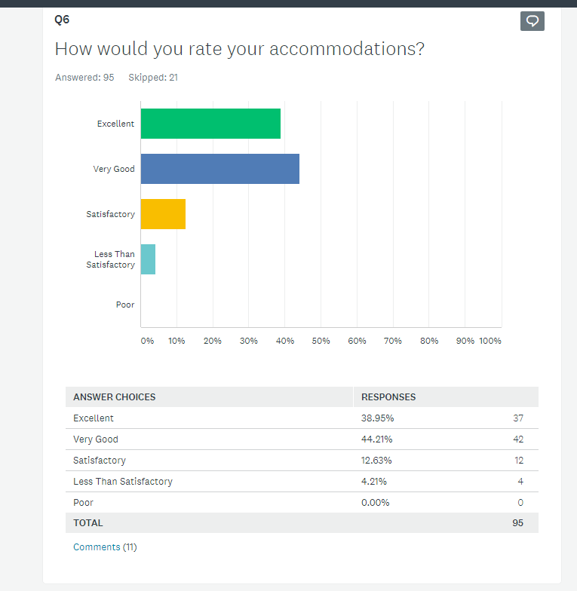
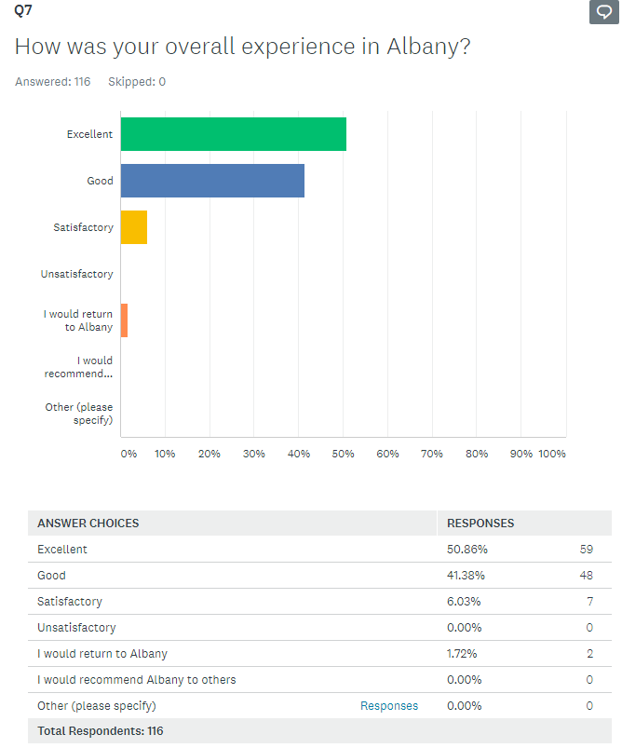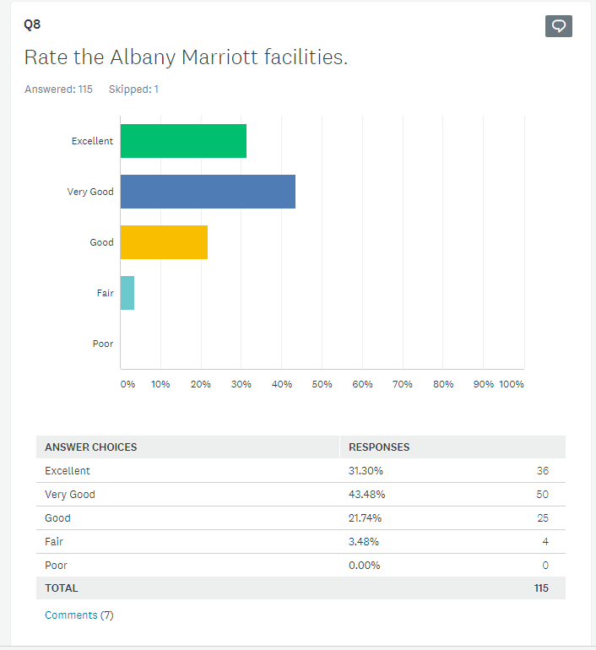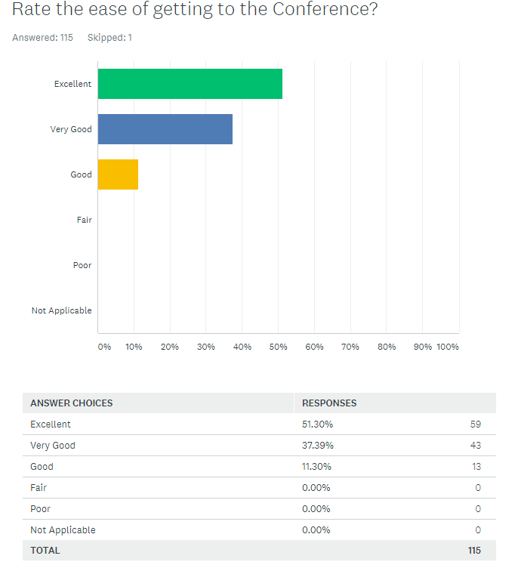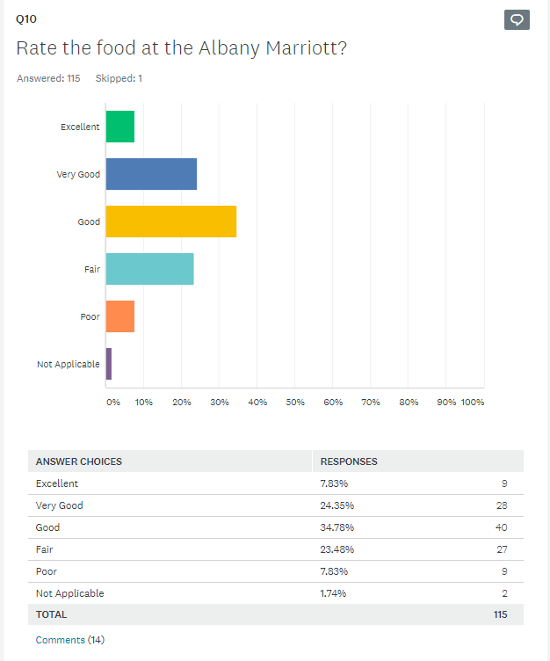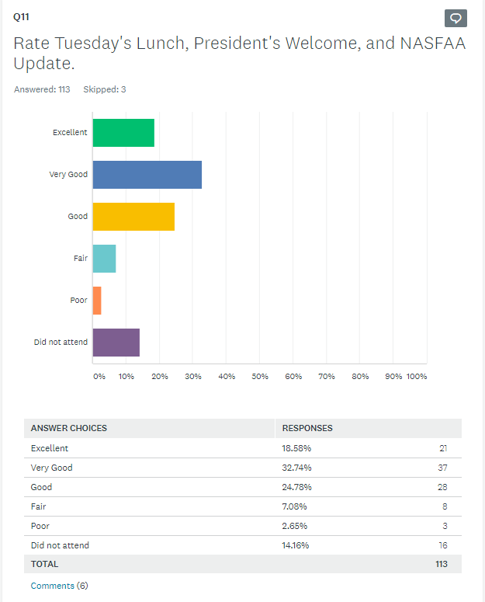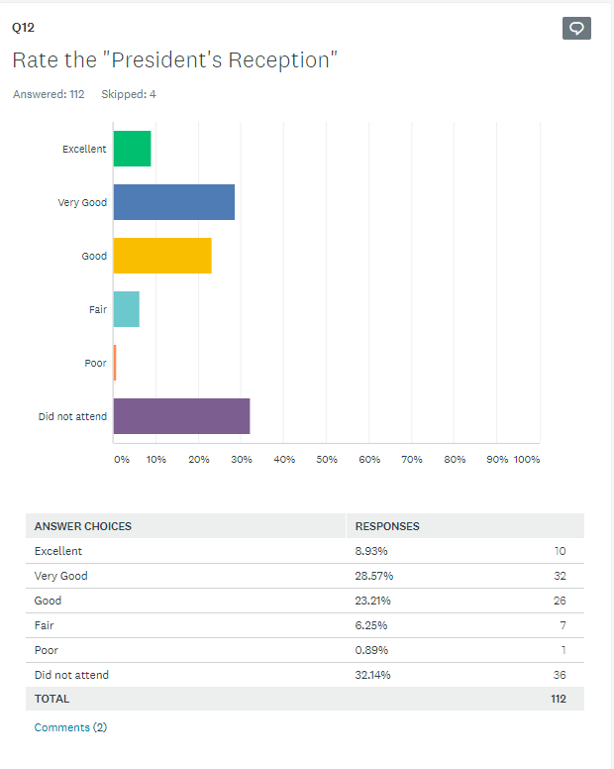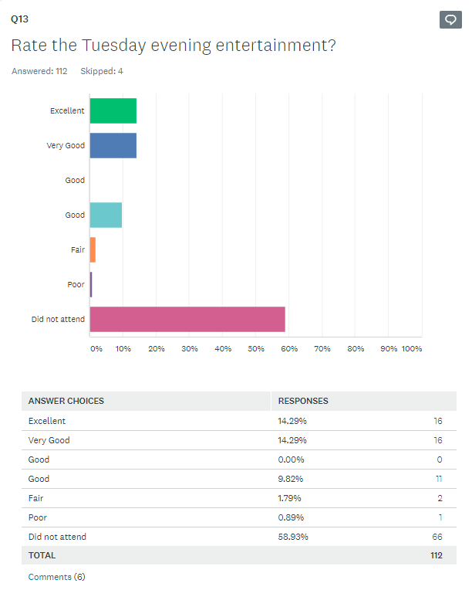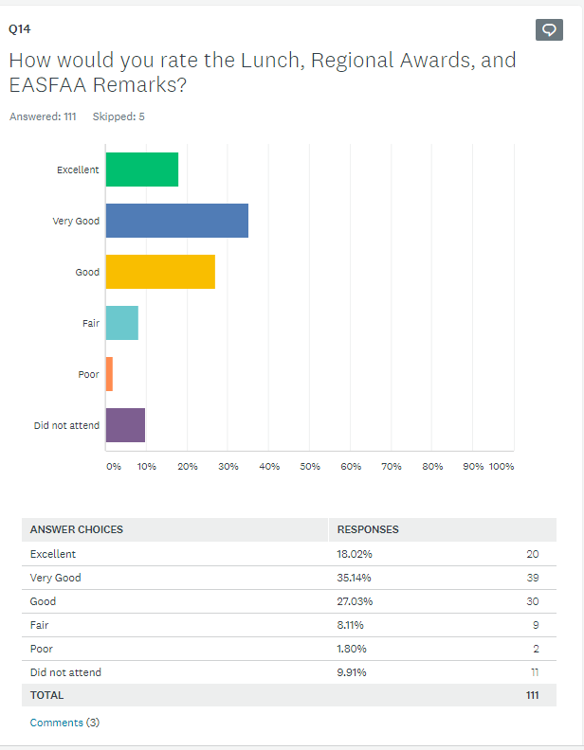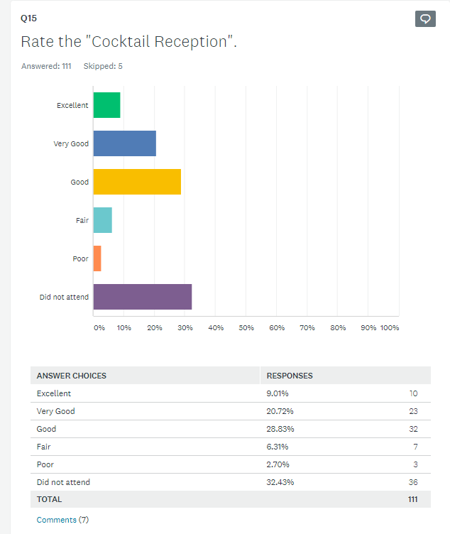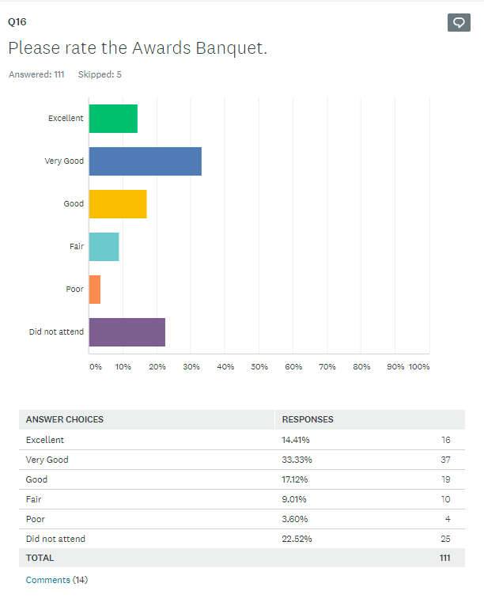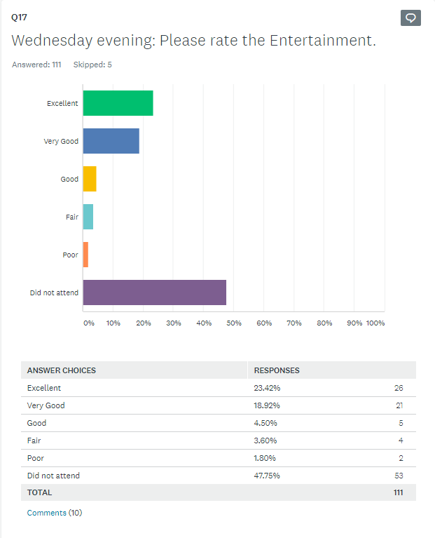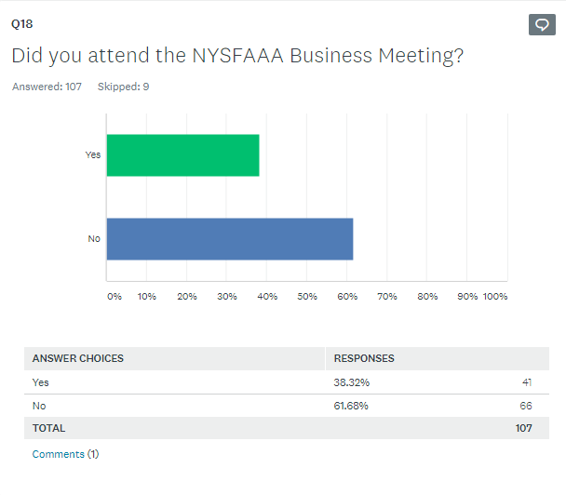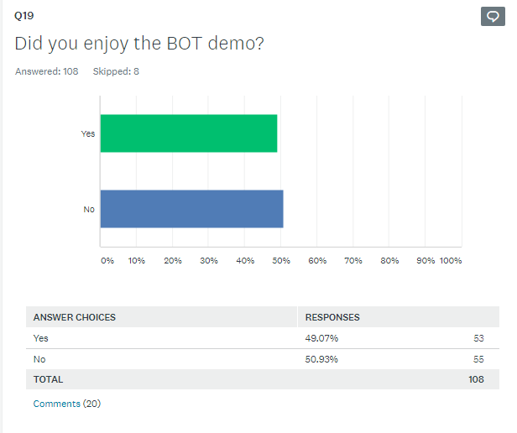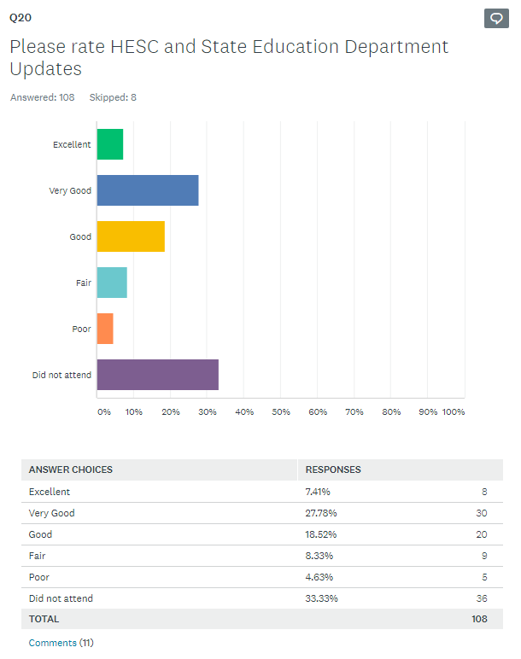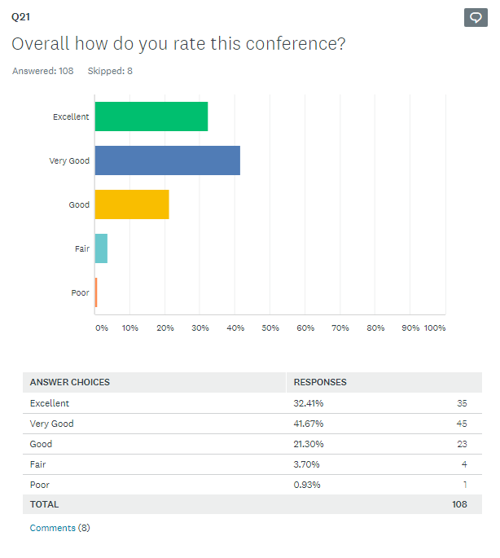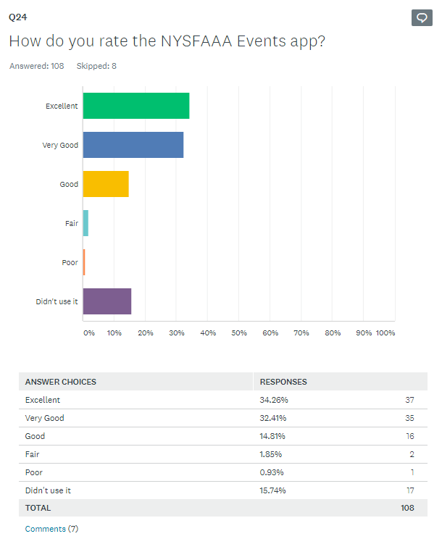

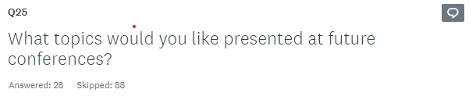
Excelsior, TAP, DREAM
11/12/2019 12:20 PM
As this is a NY specific conference, I would like another session on TAP. Perhaps how best to assist students with resolving common errors (such as residency review questionnaires and missing signatures) or a session regarding Jose Peralta or the Excelsior Scholarship.
11/12/2019 11:20 AM
More HESC sessions to address IVP process.
11/11/2019 3:34 PM
Verification
11/11/2019 10:21 AM
Session on How to get Involved with State & Federal advocacy efforts
11/8/2019 5:28 PM
TAP (all areas from application, appeals, reports, certification)
11/8/2019 4:55 PM
Continue with the professional 'career development topics. Attended 2 of these sessions on Wed. and both very well attended with great interaction.
11/7/2019 12:26 PM
Customer Service, Verification and Tax Code should be an overall training not just a workshop
11/5/2019 12:14 PM
20-21 verification
11/4/2019 3:34 PM
more on athletic compliance; one stop and customer service models
11/4/2019 2:26 PM
More on State awards. More on taxes and Verification.
11/4/2019 2:03 PM
tap/excelsior q and a
11/4/2019 1:17 PM
Breaking down the Financial Aid Administrator information section on the ISIR
11/4/2019 9:39 AM
State Aid
11/1/2019 3:45 PM
Professional development, Team building
11/1/2019 3:00 PM
clock hour, financial aid for adult education programs at a BOCES
11/1/2019 12:56 PM
Not sure right now - will think about it.
11/1/2019 12:35 PM
The verification and tax return sessions should be mandatory for everyone. Maybe a session about the CSS Profile.
11/1/2019 11:38 AM
Additional compliance how-to's
11/1/2019 11:19 AM
I would love to model NASFAA's idea of working groups where we could come back to our school with actual products that we've created or improved.
11/1/2019 11:17 AM
Veteran Benefits- I wasn't able to get there early enough Tuesday to attend but would have liked to.
11/1/2019 9:59 AM
More statewide issues like Excelsior/ETA
11/1/2019 9:50 AM
SAP with examples of how to calculate SAP; what do "other" institutions do
11/1/2019 9:48 AM
Specifics on loan/Pell monthly reconciliation: how do other schools do it so I know I'm doing it efficiently (or not). What tools do they use? Specifics on how other schools handle SAP appeals; what do you consider, what don't you consider, makeup of committee (if there is one), etc. How do schools handle exit counseling?
11/1/2019 9:11 AM
Open Forum about different topics.
11/1/2019 7:32 AM
More NYS updates Opportunity to meet with other private schools that is during the conference (not before the conference) Counseling students/retention
10/31/2019 6:02 PM
Perhaps a more hands on event with HESC, utilizing their website, how to certify a student for TAP, what can go wrong with a student's award so we as an institution can help the student successfully receive their TAP award.
10/31/2019 12:44 PM
Customer Service Diversity
10/30/2019 9:51 PM

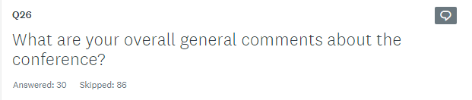

Overall a good facility and decent agenda.
11/12/2019 12:20 PM
I sincerely enjoyed the conference. The venue was easily accessible and well organized, and the sessions were helpful.
11/12/2019 11:20 AM
Good Conference with great selection of break out selections
11/12/2019 9:09 AM
Overall, it was a very good conference. The hotel and food were very good.
11/11/2019 3:34 PM
Excellent Keynote Speaker! Great tributes to NYSFAAA folks we lost! Loved the therapy dogs, the vendor setup, and the seamless execution of the conference.
11/8/2019 5:28 PM
Very Good.
11/8/2019 4:55 PM
Easy to negotiate the venue with meeting rooms, vendors, and meals all in ONE area of the hotel.
11/7/2019 12:26 PM
It was informative depending on the topic.
11/5/2019 12:14 PM
The conference was very informative and the speakers were good.
11/5/2019 9:13 AM
It was truly excellent. I was so proud to attend.
11/4/2019 2:03 PM
Was much more informative than I thought it would be
11/4/2019 1:17 PM
The committee did a nice job!
11/4/2019 9:57 AM
Overall, I thought the conference went well and there was a good variety of presenters.
11/1/2019 4:03 PM
I would like to see hear more about State Aid
11/1/2019 3:45 PM
Always a very well organized event. Thank you for the time and energy put in.
11/1/2019 3:00 PM
Entertainment committee did a great job!
11/1/2019 2:24 PM
The added interjections from Howard really need to be addressed. It's disruptive and unnecessary in most instances. He is the president of our organization yet feels the need to speak out of turn just because. It is uncomfortable for the speaker(s) and for the audience.
11/1/2019 2:02 PM
Well done - excellent!
11/1/2019 12:35 PM
Loved the vendors being in the open area. Allowed for members to interact more.
11/1/2019 11:58 AM
Great Conference - well organized.
11/1/2019 10:41 AM
fair
11/1/2019 9:59 AM
The conference was ok. I had a hard time choosing what to attend. Not because I wanted to attend multiple but more because none of the topics really jumped out at me.
11/1/2019 9:59 AM
As a vendor I was disappointed in the vendor area as there was a very large difference between being in the front of the hall prior to the hall or in the back of the hall after the entrance. Also, there was very little participation in the conference game.
11/1/2019 9:52 AM
I thought that the Conference was very well organized, and the topics were great.
11/1/2019 9:50 AM
It was a very good conference and I commend the conference committee. I know how much work it is and for volunteers it is nothing short of amazing!
11/1/2019 9:50 AM
Very Good
11/1/2019 9:48 AM
Although I gain new information each year I attend, I feel as though conference sessions are too broad, too much geared toward the beginner. I would like to see more specific topics covered regarding what schools do to meet federal requirements, how do they track/monitor/record keep etc.
11/1/2019 9:11 AM
excellent
11/1/2019 7:32 AM
Very good!!! Great innovative ideas for the fundraiser for the scholarship! Lots of fun freebies from the vendors too.
10/31/2019 12:44 PM
Many of the trainings are for administrators with limited experience or with schools that may have smaller populations. Coming from a large NY school some of the sessions included topics that we have already explored.
10/30/2019 9:51 PM

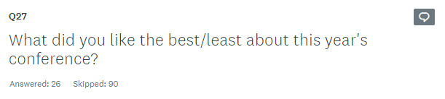
Best--networking opportunities, especially after sessions over. The two nights' entertainment managed to get a lot more people than usual to hang around. Least--toss-up between the temperature in the conference areas, or some of the extended breaks between sessions. Unless something special is going on like a snack/coffee break, 15 minutes is plenty of time between sessions.
11/12/2019 12:20 PM
I enjoyed the NYSFAAA application.
11/12/2019 11:20 AM
Very organized and welcoming.
11/12/2019 9:09 AM
It's better when the vendors are in a room rather than a cramped hallway. The meals were somewhat non-traditional and were very good
11/8/2019 4:55 PM
Excellent variety of sessions. Heather's presentation (Emotional Intelligence) was excellent and should be presented regularly.
11/7/2019 12:26 PM
Best: New Tax Code and SAP presentation Least: Keynote speaker
11/5/2019 12:14 PM
The food was not my favorite but the overall conference was great
11/5/2019 9:13 AM
Best - The People, the hotel, the events Least - The food
11/4/2019 2:03 PM
Trivia was best! Zach's sessions were most informative Least, some rooms were too small, not enough seats
11/4/2019 1:17 PM
least: the food
11/4/2019 12:24 PM
Best= networking / vendor space Least = ?
11/1/2019 3:00 PM
the bar area set up - seemed like a big lunch room, banquet meal was not great.
11/1/2019 12:35 PM
Best - All meetings, meals, vendors, etc. were in one location. No need to move all over the hotel to find a room. Least- food - the choices were fine, but the quality was not the best. The staff at the hotel, however were excellent.
11/1/2019 11:58 AM
The trivia was amazing - I recommend bringing that back the first night instead of bingo and having a band for after the formal dinner.
11/1/2019 11:17 AM
Entertainment was very engaging and seemed like those that attended enjoyed it very much.
11/1/2019 10:41 AM
Loved the therapy dogs - need at every conference. Just the right amount of food.
11/1/2019 10:41 AM
Friends from other schools
11/1/2019 9:59 AM
The Marriott was a nice hotel. The topics covered weren't great.
11/1/2019 9:59 AM
I liked everything about the conference.
11/1/2019 9:50 AM
It was hard to find the first break on Tuesday because it was up against the wall and people just looked down the hall and didn't see it so assumed it wasn't there.
11/1/2019 9:50 AM
Erin Gruwell's presentation; food; topics and presenters all very good! least-don't want to feel compelled to speak to the lenders but I realize they help support the event
11/1/2019 9:48 AM
my favorite was the living in a multimedia world- discussing what works best for gen Z.
11/1/2019 9:43 AM
Very good location but banquet dinners were ..... terrible. Only one person at our table ate their meal. Also, maybe I'm getting too old, but Tuesday entertainment started late.
11/1/2019 9:11 AM
food
11/1/2019 7:32 AM
Best - Zack Goodwin's talks Least - Food
10/31/2019 6:02 PM
Least Freedom Writer session Best Higher Ed Committee of 50 and both fed update sessions.
10/30/2019 9:51 PM

Tighten up the gaps between sessions unless it's a coffee break.
11/12/2019 12:20 PM
I think this year's conference was great! One idea would be to set time aside for brainstorming sessions where schools can discuss issues that they are facing and obtain ideas/input from other institutions.
11/12/2019 11:20 AM
Include smaller specific round table topics vs lecture style training.
11/12/2019 9:09 AM
1. Please schedule more vendor specific break time. 2. On attendee lanyards please print attendee name and school much larger.
11/11/2019 9:47 AM
Have another pre-conference NASFAA credentials training so each year members can add a new credential to their resume
11/8/2019 4:55 PM
Finding out what some colleges/universities find challenging to incorporate this into the conference and gearing workshops towards those concerns.
11/5/2019 12:14 PM
The conference can be more interactive than just it being a presentation.
11/5/2019 9:13 AM
Larger session rooms. Bag lunch on Thursday. Pitchers of water on the tables at meals.
11/4/2019 1:17 PM
Consider options for non-dairy or non-gluten attendees.
11/4/2019 9:57 AM
With these new changes in State Aid, would have like additional information on what other school are doing. How other school helping to assist undocumented/Daca students
11/1/2019 3:45 PM
Nothing - this conference was well planned, a lot of great ideas and it showed. the sessions were great and the feedback I heard was positive. next year should try to be as great!
11/1/2019 12:35 PM
Hart to say. Recommend they review all the surveys and do their best to work on any negative comments
11/1/2019 11:58 AM
shorter speeches
11/1/2019 9:59 AM
More variety for topics covered.
11/1/2019 9:59 AM
During the registration process please separate the registration for any excursion (like the museum trip) from the regular conference registration. Some schools will not cover it but it couldn't be done separately. It was difficult to deal with the school on this. Other than that, the process was very smooth!
11/1/2019 9:50 AM
Have more specific examples/issues rather than general overviews regarding financial aid processes/regulations.
11/1/2019 9:44 AM
Too much time allotted for breaks. Lunch ended 1.5 hours early on Wednesday. Schedule could have been streamlined.
11/1/2019 9:42 AM
Please don't have the conference end or take place on Halloween in the future. It's difficult for those with small children. Please also consider having coffee during all breaks. It seemed like it was only available in the morning.
11/1/2019 8:58 AM
I likely won't attend, since Long Island is so far from Upstate New York.
10/31/2019 6:02 PM
serve breakfast on the first day
10/31/2019 1:22 PM
For the sessions indicate who the session is geared toward. Administrators with limited experience etc. Diversity session. For the limited number of administrators of Color, it would be nice to have a session or cocktail for people to meet. A session on how to become an OFA director; what to know about fisap, budgeting etc for those that have been in the industry over 15 years looking to explore next steps. Mentoring for those in these situations.
10/30/2019 9:51 PM

Development Committee Exhibits
Edunion LLC Proposal to NYSFAAA

April 4, 2020

To: Howard Leslie, President
Tami Gilbeaux, Development

Presented by: Philip I. Waitzman MBA, MPH, MA, CEO and Principal Consultant

Dear Howard and Tami,

Thank you for the opportunity to present the following proposal to NYSFAAA. From our conversations, I understand that NYSFAAA is aiming to identify and enhance revenue to support the organization’s mission to serve its members. The information presented within this proposal will identify examples of new revenue streams and will discuss opportunities to enhance current revenue channels. The proposal will suggest generating revenue from existing relationships, partners, members, and stakeholders while also setting financial goals that utilize a strategic, proactive process that aims to achieve those goals through new pathways.

From our discussions, I understand your goals for new revenue to include: Year 1 - $50,000, Year 2 - $75,000, Year 3 - $100,000. Currently NYSFAAA’s revenue comes from membership dues, and vendors that participate at NYSFAAA’s annual conference and other service fees. This past year, 25 vendors paid $700 to exhibit or $17,500. From review of previous 990s, NYSFAAA has historically managed a budget of roughly $250,000 annually. Infusing an additional $50,000-100,000 in annual revenue would provide a significant lift for the organization.

As a member organization, NYSFAAA provides member benefits including but not limited to: access to continuing education, training and development at an annual event, regional trainings and webinars, a job site, internal volunteer opportunities through committee membership. Information is also available to the general public on financial planning for college.

Upon review of the website and after discussions with Tami and Howard, the following opportunities exist to expand NYSFAAA offerings and partnerships; thus generating additional or new revenues. To further understand member, vendor and supporter interests and to develop these opportunities, it is recommended that NYSFAAA survey its current and past membership, vendors and supporters on the topics of interests, needs and several other categories that could tie to future offerings and benefits. This data will help to prioritize development of future programs, services and offerings.

Revenue Opportunities:

Membership Categories: widen membership categories to include individuals and organizations (i.e. Individuals - Financial aid officers, guidance counselors, general public, other university staff, etc.; Universities – University Enterprise System or individual departments)

Job Site: partner with a wider reaching and robust job platform(s) that offers jobs across departmental functions (i.e. Higheredjobs.com, insidehighered.com, etc.). While NYSFAAA intends to serve the
financial aid officers at universities, NYSFAAA could position itself as a centralized point for members to access to all types of jobs available within university settings.

Corporate Partnerships: in lieu of offering membership to industry partners, create an industry corporate partnership program with offerings that correlate to contribution tiers. For example, annual giving of $5,000, $10,000, $25,000, and $50,000.

Annual Event Vendors: This may be tied to the Corporate Partnerships offerings. In addition to the $700 for exhibiting at the annual event, layer in additional marketing offerings and costs for greater benefits offerings.

Consulting: Create a centralized consulting program whereby members and non-members who are individuals, organizations, or the general public can hire members for consulting. NYSFAAA would build in a revenue share structure for providing this matching service.

Licensure/Training and Development: partner with the national association or develop a uniquely branded licensure that then provides education, training and benefits to practicing as a financial aid officer. Tie the licensure and training to ongoing college credit towards achieving certificates or advanced degrees to a partner university.

Edunion’ s role in helping NYSFAAA to further these opportunities starts with member and stakeholder engagement. Once data is collected, a more in depth recommendation to the Board can be made. The Board can then select recommended programs, services and offerings that would be created for its membership, vendors and supporters. Edunion would drive this process forward while working with appropriate Board members, committee members, members and vendors to develop content and structure for future programs, services and offerings.

Phase 1 –

$5,000 plus any travel related expenses
- Survey (May, 2020): current and past members on member benefits and offerings current and past vendors and industry partners on current and ideal offerings for an expanded relationship with NYSFAAA *Should the volume of data gathered prove to be insufficient, Edunion will conduct focus groups.

- Written report to the Board (late May, early June, 2020) offering detailed recommendations for future revenue opportunities through membership, partners and other industry relationships. In addition to the written report, Edunion offers an optional virtual presentation to the Board.

Phase 2 – Cost TBD
- Board to select the programs, services and offerings from the list of recommendations to be developed.
- Edunion to work with the Board and Committees to utilize data gathered to develop programs, services and offerings
- Incorporate Affiliates if needed for development of functional areas
- Testing and measure member and vendor satisfaction
- Ongoing reporting to the Board of Directors regarding progress and other key updates

About Edunion

Edunion LLC is a boutique consulting firm aiming to help purposefully focused organizations to maximize their mission’s potential strategically, operationally, financially and programmatically. With an emphasis on solving the business and organizational challenges, Edunion collaborates with our clients and their closely related parties to identify challenges and solutions ranging from small problems to large organizational challenges. Edunion is a sole proprietorship that acts as the key partner for both understanding our client’s challenge while developing the plan aimed at solutions. When focused on functional areas, Edunion leverages its affiliates to lead in core areas such as fundraising, legal, HR, finances and beyond.

Led by Philip I. Waitzman MBA, MPH, MA, LSW, Edunion LLC focuses in the areas of professional associations, nonprofits, higher education and professional services. Our modernized approach breaks the traditional mold and moves to a strategic proactive business minded way of driving mission centered organizations. Edunion’s most recent engagements have included nonprofit organizations, schools and associations across industry segments with needs ranging from strategic growth, Board development, management, marketing, enrollment and fundraising to program development. Prior to Waitzman’s consulting work, he served as President and CEO of Vision Share, a mid to large sized transaction oriented global healthcare Members Association. His work in Associations has also included leading the Development and Fundraising department at American Orthopedic Association. With roots in Corporate America, Waitzman has since served in several key roles in Professional Services, Start Up, Healthcare and Higher Education.

Proposal accepted by:
4/4/2020

NYSFAAA Authorized Signor and date

Edunion LLC Authorized Signor and date

